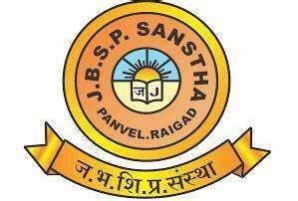

*(For Internal Circulation only)*

InfoBizz

(An annual magazine)

Janardan Bhagat Shikshan Prasarak Sanstha’s

Ramsheth Thakur College of Commerce and Science, Kharghar, Navi Mumbai

**Management Association**

**of**

**Department of Management Studies**

**presents**

|  |  |
| --- | --- |
| Editorial Board   * Dr. Reet Thule (Chief Editor)   Editorial Team   * Mr. Rewan Shinde * Mr. Vishal Deshmukh * Mrs. Ankita Jangid * Mrs. Divya Namboothiri * Dr. Dhanvi Awate * Mrs. Aarti Kagwade   Month of Publication – October 2023  Volume- II  Issue-I | * InfoBizz magazine is published by the Department of Management Studies of Ramsheth Thakur College of Commerce and Science, Kharghar, Navi Mumbai once in a year. * All Rights Reserved. * The views expressed in this publication are purely personal judgments of the authors and do not reflect the views of publisher. * All efforts are made to ensure that the published information is correct, however publisher is not responsible for any errors caused due to oversight or otherwise. |

Published by - Principal

Ramsheth Thakur College of Commerce and Science

(A Self-Financed Unit of JBSP Sanstha, Panvel)

Plot no. 1, Sector 33, Near Pethpada Metro Station,

Kharghar, Navi Mumbai.

**Management Association**

Management Association of RTCCS acts as a forum for inculcating profound learning in the field of management and leadership roles.

It focuses on conducting stimulative activities for enhancing the skills of the students and improving their academic-industry interface.

Members of Management Association





Mrs. Aarti Kagwade

Asst. Professor of Marketing - BMS Dept.

Dr. Reet Thule

In Charge- Management Association

Asst. Professor of Human Resource- BMS Dept.

Mrs. Dhanvi Awate

Asst. Professor of Human Resources- BMS Dept.

Mrs. Divya Namboothiri

Asst. Professor of Human Resources- BMS Dept.

Mr. Vishal Deshmukh

Asst. Professor of Finance- BMS Dept.

Mr. Rewan Shinde

Asst. Professor of Marketing- BMS Dept.

Mrs. Ankita Jangid

Asst. Professor of Finance- BMS Dept.

Best Wishes from Secretary –JBSP Sanstha



**A warm welcome to all the readers of this magazine…“InfoBizz”.**

The influence of college life on students cannot be overstated. It is the juncture at which students make critical career decisions and prepare to chart their paths to success. At Ramsheth Thakur College of Commerce and Science, Kharghar, we take pride in our role as facilitators in our students' career journeys. We achieve this by exposing them to real-world challenges and equipping them with cutting-edge technology, including ICT, updated software, hardware, and robust internet facilities.

Effective management techniques have proven to be transformative for organizations, reshaping the landscapes of economics and commerce. Throughout the years, our institution has been dedicated to fostering steady growth across the spectrum of academic, co-curricular, and extension activities. We offer abundant opportunities for our students to showcase their talents and skills, and they consistently rise to the occasion, surpassing expectations.

I would like to extend my heartfelt appreciation and congratulations to the dedicated faculties of the Department of Management Studies on the release of the second edition of our annual magazine, "InfoBizz." The Management Association established by the Department of Management Studies is committed to honing the managerial skills of our students, empowering them to embark on career paths that lead to leadership roles.

We are deeply committed to instilling in our students a profound sense of professional ethics and academic values. It is our sincere hope that all our endeavors will foster these qualities in our students. Through "InfoBizz," we aspire to inspire a profound understanding of effective management practices among our readers. This publication is a testament to our dedication to providing valuable insights and knowledge in the field of management.

All the best!

**Dr. S. T. Gadade**

Secretary, JBSP Sanstha

From Principal’s Desk



InfoBizz - Nurturing a Culture of Research

As we embark on this exciting journey with InfoBizz, the research journal published by Department of Management Studies’ Management Association of Ramsheth Thakur College of Commerce and Science (RTCCS), we celebrate the spirit of inquiry, exploration, and knowledge dissemination. This magazine stands as a testament to our commitment to nurturing the research acumen of our students and faculty members, and it signifies a new beginning in the pursuit of intellectual growth and excellence.

The success of InfoBizz would not have been possible without the dedicated efforts of the Management Association and the entire team of the Department of Management studies. Their unwavering commitment to this initiative has been nothing short of inspiring. They have not only encouraged our students to contribute articles but have also motivated our esteemed faculty members to share their expertise and insights through their own research contributions.

In the world of academia and research, it is often said that "There is a wave behind every tide." This adage beautifully encapsulates the essence of InfoBizz. Every student and faculty member at RTCCS is a vital part of this wave, diligently collecting information, conducting research, and transforming their findings into well-crafted articles. It is through their collective and relentless efforts that InfoBizz has taken shape, emerging as a beacon of knowledge and innovation. This journal will serve as a source of inspiration and a valuable resource for all those who seek to expand their horizons, question the status quo, and delve deeper into the world of research and scholarship.

As we look ahead, our best wishes go out to InfoBizz for its continued success and its vital role in fostering a culture of research and academic excellence within our institution.

**Dr. Rupendra R. Gaikwad**

From Editor’s Desk



Dear Esteemed Readers,

Warm greetings to all of you!

I'm immensely proud and honored to be a part of the second volume of the Management Association’s Magazine, "InfoBizz." The beginning of a new academic year represents a fresh start, a canvas of new possibilities, and a heightened focus on purpose. We find ourselves in a time where the world is constantly evolving, and the academic and industrial landscapes are experiencing significant changes.

In this second volume, our talented contributors have expressed their thoughts, ideas, hopes, emotions, aspirations, and convictions through their creative expressions. We are delighted to present to you the second volume of "InfoBizz," an annual magazine brought to you by the Management Association of the Department of Management Studies. From our dedicated faculties and talented students, we bring you a diverse array of insightful and inspiring articles spanning the realms of business, research, management, and leadership.

We extend our sincere gratitude to all the contributors for their unwavering support and enthusiasm.

Wishing you a most enjoyable and enriching reading experience!

Warm regards,

**Dr. Reet Thule**

Chief Editor

BMS Departmental Magazine

"InfoBizz" (Volume II)

Table of Content

|  |  |  |  |  |
| --- | --- | --- | --- | --- |
| **Sr. No.** | **Title of Article** | **Name of Author** | **Class / Designation** | **Page No.** |
| 1 | Work-Life Balance of Couples During and Post COVID-19 | 1. Ms. Antule Naufa Ilyas | SYBMS, RTCCS, Kharghar |  |
| 2 | Empowering Management | 1. Ms. Damini Kadam | TYBMS-HR, RTCCS, Kharghar |  |
| 3 | Navigating the Hectic Life of HR Professionals: Strategies for Balance and Success | 1. Ms. Janvi Balraj Yadav | TYBMS-HR, RTCCS, Kharghar |  |
| 4 | Pattern of (Anti) Corruption Mechanism within Informal Networks | 1.Aditya Lokhande | TYBMS – HR, RTCCS, Kharghar |  |
| 5 | Empowerment-in-Management | 1.Anvi Paradkar | FYBMS, RTCCS, Kharghar |  |
| 6 | Our Employees – “The Most Valuable Intangible Assets” | 1.Akberali Masalawala | TYBMS – Finance, RTCCS, Kharghar |  |
| 7 | HR- Management: “An Art and Science” | 1.Sanika Pal | FYBMS, RTCCS, Kharghar |  |
| 8 | “Jugaad Management: Navigating Innovation and Resourcefulness in Modern Business” | 1.Dr. Reet Thule | Head of the Department, Department of Management Studies, RTCCS, Kharghar |  |
| 9 | STOCK MARKET: What and How of It | 1.Sania Sameer Logde | SYBMS – Finance, RTCCS Kharghar |  |
| 10 | Financial literacy - Path to Financial Freedom | 1.Mrs. Ankita Jangid | Assistant Professor, RTCCS, Kharghar |  |
| 11 | The Cash Reserve Ratio's Ripple Effect: Impact on Bank Profitability | 1.Vishal Deshmukh | Assistant Professor, RTCCS, Kharghar |  |
| 12 | LUXURY BRANDS and FDI | 1.Zoha Kapadi | FYBMS, RTCCS Kharghar |  |
| 13 | Maximizing Brand Potential: The Power of Digital Marketing | 1.Aiman Mukri Anis | FYBMS, RTCCS Kharghar |  |
| 14 | Service Quality of Internet Banking | 1.Nikita Jadhav | FYBMS, RTCCS Kharghar |  |
| 15 | Principles of Marketing- The Basic Concept | 1.Rukmuddin Mehboob Shaikh | FYBMS, RTCCS Kharghar |  |
| 16 | Digital marketing evolution | 1.Jeeva Mule | TYBMS - Marketing, RTCCS, Kharghar |  |
| 17 | “Revolutionizing Marketing: The Impact of Technology on Modern Strategies” | 1.Disha Jadhav | TYBMS - HR, RTCCS, Kharghar |  |
| 18 | Marketing: Impact of AI on Brand Promotion | 1.Rewan Shinde | Assistant Professor, RTCCS, Kharghar |  |
| 19 | The Power of Being Educated | 1.Aditi Chaudhari | FYBMS, RTCCS, Kharghar |  |
| 20 | The Fusion of Technology and Commerce: Empowering the Modern Commerce Student. | 1.Sadaf Sajid Jable | FYBMS, RTCCS, Kharghar |  |
| 21 | Importance Of Business Management | 1.Namra Khan | FYBMS, RTCCS, Kharghar |  |
| 22 | Mobile Phone – “The New External Human Organ” | 1.Akash Bogati | SYBMS - Finance, RTCCS, Kharghar |  |
| 23 | The Business Model of Bollywood Films | 1.Chandni Khan | TYBMS -HR, RTCCS, Kharghar |  |
| 24 | The Power of Keywords in Business: Unlocking the Potential | 1.Anuradha Chaudhary | FYBMS, RTCCS, Kharghar |  |
| 25 | Everything I learnt about AI | 1.Ketki Patil | TYBMS - HR, RTCCS, Kharghar |  |
| 26 | Expansion of Indian Railways | 1.Tejas Deshpande | TYBMS - Finance, RTCCS, Kharghar |  |
| 27 | The Role of Literature in Human Life | 1.Safina Khan | SYBMS – Marketing, RTCCS, Kharghar |  |
| 28 | Humanity is the Essence of our Existence | 1.Rubina Khan | SYBMS – Marketing, RTCCS, Kharghar |  |
| 29 | Role of Social Media in Boosting Women Entrepreneurship – The Indian Scenario | 1.Divya Namboothiri | Assistant Professor, RTCCS, Kharghar |  |
| 30 | Terrorism and Its Global Impact on Businesses | 1. | SYBMS – Marketing, RTCCS, Kharghar |  |
| 31 | Risk Management Strategies for Managers | 1.Khushi Jaiswal | FYBMS, RTCCS, Kharghar |  |
| 32 | The Importance of Practical Experience in Business Management Studies | 1.Arpit Gupta | FYBMS, RTCCS, Kharghar |
| 33 | The Art and Science of Business Management | 1.Shivam Yadav | FYBMS, RTCCS, Kharghar |

** Work-Life Balance of Couples During and Post COVID-19**

**1. Ms. Antule Naufa Ilyas**

FYBMS, RTCCS, Kharghar

**Abstract: -** The outbreak of the COVID-19 pandemic reshaped the way people work and live, challenging the concept of work-life balance. This article examines how couples have coped with this shift during the pandemic and explores potential strategies for maintaining balance in the post-COVID era.

**Keywords: -** COVID-19, Work-life Balance, Couples

Work-Life Balance During the Pandemic

* Blurred Boundaries: Couples found themselves working side by side, often struggling to differentiate work hours from personal time.
* Childcare and Household Responsibilities: With schools and day cares closed, couples faced increased childcare and household responsibilities. Balancing work commitments with tending to needs of children added strain to daily routines.
* Communication Challenges: As couples navigated remote work, communication gaps emerged due to the lack of non-verbal cues and increased screen time.
* Burnout and Stress: Juggling work, home, and health concerns took a toll on mental health. Burnout and stress levels escalated as work and personal life collapsed.
* Lack of Personal Time: Couples struggled to find time for individual interests or self-care, leading to a sense of monotony and the loss of personal space.

**Work-Life Balance Post-COVID:** Hybrid Work Models: Many companies adopted hybrid work models, allowing employees to work both remotely and from the office. Couples can now plan their schedules to balance remote and in-office work days.

* Re-establishing Boundaries: Couples can designate specific areas for work, establish set working hours, and avoid work-related discussions during personal time.
* Open Communication: Couples should openly discuss their work commitments, personal needs, and potential conflicts to find mutually agreeable solutions.
* Shared Responsibilities: Equitable distribution of chores such as household tasks and child care can help alleviate the burden on both partners.
* Prioritizing Self-Care: Encouraging each other to prioritize self-care activities can contribute to individual well-being and strengthen the relationship.

**Conclusion:** The COVID-19 pandemic challenged couples to find a new equilibrium in their work-life balance. As the world transitions into a post-pandemic era, the lessons learned can serve as a foundation for couples to build healthier and more resilient routines.

**References:**

1. Harvard Business Review

**Empowering Management**

**1. Ms.** **Damini Kadam**

TYBMS-HR, RTCCS, Kharghar

**Abstract:** The “new normal” in particular will pose challenges for managers and department heads. Not only will they have to adapt their management style to accommodate remote working arrangements, they’ll also have to learn how to hire remotely, keep employees engaged, and play a part in their professional development.

**Keywords: -** Empowerment, Rights, Corporate Vision

**What can HR do to help?**

Monitor employee satisfaction through regular check-ins and surveys and provide this data to managers. Additionally, they can empower managers by offering them ongoing training and ensuring they have the right tools and technology to effectively do their work.

**Definition**

Empowerment is about creating working conditions where employees develop the skills to take initiative and exploit their full potential to create value for a company. The 3 conditions of empowerment: corporate vision, autonomy, and appropriation.

Why is it important to have a clear corporate vision before implementing empowerment?

A corporate vision allows a company to share its goals along with a path to follow.Knowing this vision helps employees to make quick and informed decisions. This helps to develop a sense of belonging where everyone works towards a common goal.

Ultimately, a well-defined corporate vision makes your employees more efficient and motivated.

**Examples of corporate visions:**

To reach 750,000 dollars in turnover on the US market within 2 years; receive an ISO9001 certification before the end of the year; increase customer satisfaction by 20% by 2022.Give employees a sense of autonomy

For years, businesses used to implement increasingly detailed and complicated processes to be more productive, often leaving less and less room for autonomy and decision-making.

By using empowerment in business, you are going in the opposite direction by creating space to give your employees a sense of autonomy.

Ensure that the empowerment is well appropriated

Every employee is different and will not have the same ability to appropriate this new autonomy that is granted with empowerment.

This appropriation will depend on multiple factors for each employee. This includes their hierarchical position in the company, their job, the company context, their skills, experience, and personal aptitudes.

It is, therefore, necessary to make sure that all stakeholders are comfortable with empowerment, that they feel free to use their skills and are ready to innovate to achieve their goals.

To do this, it is recommended to set up a management style that: includes a framework that lists the skills and tasks of every employee, gives them the resources to meet their goals (equipment, training, etc.), encourages initiative, risk-taking and the right to make mistakes, relies on trust by taking a step back and delegating some of its authority, acknowledges efforts made and applauds successes, measures the efficiency of actions that promote empowerment and adapts them if necessary.

**References**

1. ‌https://www.appvizer.com/magazine/hr/employee-wellness/empowerment-in-business
2. https://study.com/academy/lesson/empowerment-in-management-definition-lesson-

 **Navigating the Hectic Life of HR Professionals: Strategies for Balance and Success**

**1. Ms. Janvi Balraj Yadav**

TYBMS-HR, RTCCS, Kharghar

**Abstract: -** This article delves into the demanding and often chaotic life of HR professionals, exploring the unique challenges they face in juggling multiple responsibilities, tight deadlines, and diverse employee needs. By offering practical strategies for managing the hectic HR role, this article aims to empower HR professionals to achieve a harmonious work-life balance and excel in their careers.

**Keywords: -** HR professionals, hectic life, work-life balance, time management, employee needs, stress management

Human resources (HR) professionals play a vital role in organizations, managing everything from employee recruitment and engagement to conflict resolution and compliance. This article sheds light on the fast-paced and often overwhelming nature of an HR professional's life, highlighting the importance of effectively managing the demands of the role.

Time Management and Prioritization- HR professionals often find themselves juggling numerous tasks and responsibilities simultaneously. To navigate this busy landscape, it's essential to prioritize tasks, set clear goals, and use time management techniques such as the Eisenhower Matrix or Pomodoro Technique. Efficient time allocation ensures that critical tasks are addressed promptly, reducing stress and increasing productivity.

Stress Management and Self-Care- The hectic nature of the HR profession can lead to burnout and high levels of stress. HR professionals must prioritize self-care by incorporating regular breaks, physical activity, mindfulness, and relaxation techniques into their routines. Adequate sleep, proper nutrition, and fostering hobbies outside of work contribute to maintaining mental and emotional well-being.

Effective Communication- Clear and efficient communication is crucial for managing employee expectations and addressing their needs promptly. HR professionals should establish open lines of communication, leverage digital tools for collaboration, and ensure that employees are informed about HR policies, benefits, and initiatives.

Delegation and Team Empowerment- HR professionals don't have to shoulder every responsibility alone. Delegating tasks to capable team members and empowering them to take ownership can alleviate the workload and foster a sense of collaboration. By distributing tasks based on strengths and expertise, HR professionals can focus on high-priority matters.

Continuous Learning and Professional Development- The HR landscape is constantly evolving, and staying updated on the latest trends, regulations, and best practices is essential. Engaging in continuous learning through workshops, webinars, conferences, and industry publications helps HR professionals enhance their skills and adapt to changing demands.

Flexibility and Adaptability- The ability to adapt to unexpected challenges is a hallmark of successful HR professionals. Embracing flexibility and agility enables HR professionals to navigate crises, policy changes, and shifting priorities more effectively.

Delegation and Team Empowerment- HR professionals don't have to shoulder every responsibility alone. Delegating tasks to capable team members and empowering them to take ownership can alleviate the workload and foster a sense of collaboration. By distributing tasks based on strengths and expertise, HR professionals can focus on high-priority matters.

Continuous Learning and Professional Development- The HR landscape is constantly evolving, and staying updated on the latest trends, regulations, and best practices is essential. Engaging in continuous learning through workshops, webinars, conferences, and industry publications helps HR professionals enhance their skills and adapt to changing demands.

**References**

1. Fisher, C. D. (2010). Happiness at work. International Journal of Management Reviews, 12(4), 384-412.
2. Society for Human Resource Management (SHRM). (2021). SHRM Essentials of Human Resources. SHRM.
3. Mckeown, G., & Andriopoulos, C. (2004). A reflexive managerial approach to teaching in business education: Insights from inside the MBA classroom. Management Learning, 35(1), 77-98.

  **Pattern of (Anti) Corruption Mechanism within Informal Networks**

**1.Aditya Lokhande**

TYBMS – HR, RTCCS, Kharghar

**Abstract: -** In this article, we propose to comprehend the corruption mechanisms of tender bidding processes in terms of Human Resource Management (HRM) practices within informal networks. Taking the context of Kazakhstan, we analyse the behaviour of individual actors as member of informal networks. Our analysis shows that both corruption and anti-corruption mechanisms can be explained in terms of HRM practices such as (camouflaged) recruitment (e.g. of powerful government officials via network ties) compensation (kickbacks of corruption, social recognition or shame for anti- corruption) and performance management (e.g. demonstrative punishment for corruption, extreme formalization peer pressure or social sanctions for anti-corruption.

**Keywords: -** Recruitment, corruption, social recognition, social sanctions, anti-corruption

To understand why standard anti-corruption policies fail and provide different insights into corruption mechanisms, some scholars suggest studying corruption as a social process and focusing on informality and informal practices. Analyse of the behaviour of individual actors as member of informal social networks allows corruption to be conceptualized in terms of power flows and relationships and corrupt transaction between individuals who are not directly linked to be understood. This is especially important to countries where indigeneous important network ties play a significant role. For example, blat/suyazi in Russia, clanism in Kazakhstan, guanxi in china, wasta in the middle East and North Africa or Yongo in Korea. While may scholars have portrayed the particularities of the indigenous informal networks in different countries, Baez Camargo and Ledenova attempted to find similarities in the way they function based on examples from Mexico, Russia and Tanzania. The conceptual framework comprises three interdependent modalities of informal governance co-optation (recruitment to the power network and redistribution of resources in favour of those who are recruited), control (ensuring discipline among the network members) and camouflage (protection of the network from external risks. These three modalities help explain the mechanisms of corruption when networks of individual actors redistribute resources in favour of the members of the network at the extend of excluded groups.

Drawing parallels between this informal governance framework and Human Resource Management (HRM) , we propose to comprehend these three modalities in terms of HRM. “HRM refers to the policy practices and systems that influence employee’s behaviour, attitudes and performance. ‘’ HRM practices comprise analysing and designing work, deciding HR needs (planning) recruitment (attracting potential employees) selection (choosing from the pool of attracting employees) training and development (teaching employees how to perform their jobs and prepare them for the future) compensation (rewarding employees) performance management (evaluating performance) and employee relations (setting positive work environment).

Thus, co-optation, one of informal governance modalities correspond to recruitment and selection based on trust, reciprocity, loyalty or kinship. Control refers to compensation (e.g. feeding practices such as providing exploitable positions in public offices) performance management (control mechanisms such as demonstrative punishment, black mail, peer pressure or social sanctions) and training and development (e.g. mentoring, job rotaton). All these practices may be camouflaged to protect the informal redistribution of resources among network members.

Graspincg the informal governance of indigenous networks through the HRM lenses allows understanding corrupt transactions of individuals as members of informal social networks. Examining how these members recruit, reward and manage corrupt performance provides more structured vision of how corruption functions.

Using examples of tender bidding processes, the objectives of this paper is to analyse the corruption mechanisms of important networks mechanisms through HRM lenses may also help in fight against corruption. Indigenous practices used by individuals networks have a negative connotation of corruption but they can also be perceived and used positively. Networks may contribute to the development of trust, mutual support and coordination efficiency. We therefore also aim to demonstrate the same HRM practices may be used to fight corruption. Consequently our research question areas follows:

How and to what extent can be corruption and anti-corruption mechanisms of a tender bidding process be explained in terms of HRM practices?

To study this research question, we took the context of the republic of Kazakhstan (henceforth Kazakhstan) where informal networks are of the utmost importance. Our paper is structured as follows. First, we present the context of Kazakhstan in terms of the use of indigenous management practices and corruption. Second, we provide the description of public procurement process in Kazakhstan. Third, we describe our methodology. Then, we present our findings followed by a discussion**.**

**References**

1. Dessler, G. (2000). Human Resource Management (8th ed.). Prentice Hall.
2. Transparency International. (2021). Corruption Perceptions Index 2020. Retrieved from https://www.transparency.org/en/cpi/2020/index/nzl

**Empowerment-in-Management**

**1.Anvi Paradkar**

FYBMS, RTCCS, Kharghar

**Abstract: -** To work in human resources, you need a combination of workplace and technical skills, such as communication, Active listening, analysis, administrative, training, technical skills and talent management systems.

**Keywords**: **-** Active listening, technical skills

Within a company, human resources (HR) is responsible for screening, recruiting, and training employees, as well as implementing employee processes. In effect, HR departments are specifically responsible for managing a company's entire employee experience, from the moment an individual applies to a position to when they begin working their, and, finally, when they leave it. HR's primary activities include recruitment, administration, compensation and benefits, training and development, and employee relations and performance management.

However, they often do much more. As a human resources professional, you support employees by providing continuing education, training, and support for health and wellbeing. Adequate human resources are key to maintaining employee satisfaction and morale. The way HR supports employees may vary from one company to another. To work in human resources, you need a combination of workplace and technical skills, such as communication, Active listening, analysis, administrative, training, technical skills and talent management systems. The specific skills you need may vary depending on the job you want.

In conclusion, the practice of HRM needs to be integrated with the overall strategy to ensure effective use of people and provide better returns to the organizations in terms of ROI (Return on Investment) for every dollar or rupee spent on them. Unless the HRM practice is designed in this way, the firms stand to lose from not utilizing people fully. And this does not bode well for the success of the organization.

**References**

1. https://study.com/academy/lesson/empowerment-in-management-definition-lesson

**Our Employees – “The Most Valuable Intangible Assets”**

**1.Akberali Masalawala**

TYBMS – Finance, RTCCS, Kharghar

**Abstract: -** While starting the journey to another financial year, let me raise an interesting question to the Corporate world- along with the stock taking of our physical goods, don't you feel it’s important to take the stock of skills level of the most valuable asset in our Organization - the Human Asset**.**

**Keywords: -** Intangible asset, Employees, Stakeholders, Productivity, Investment

While humans can be physically replaced, the skill-sets and knowledge of a person leaving an organization cannot be exactly replaced by the successor. It is widely held among business decision-makers that the skill of employees account for 85% of a company's assets. Employee skills determine the speed and success of organizations.

Most of our employees are hired to do specific functions based on current need. As the strategic direction of our organization changes, these employees (human assets) yield less and less. In other cases, employees hired for a specific function never have their full capabilities assessed or explored. Further, there is a general inability to quantify the capacity of human resources. Consequently, the organization cannot effectively determine when it has reached its affordable human asset capacity level.

It is also important for us to understand that the skill sets of our employees helped us to reach certain targets during the last financial year. It is obvious that we will set an ambitious target during this financial year probably with the same set of employees. Remember, the skills level of our people enabled us to reach here but is it enough to take us to the next level? Should we take the stock levels of skill sets they possess and address the gap if any?

Performance Reviews – a standard performance review usually includes a discussion between the employee and his or her manager to assess the competency proficiency.

Interviews – interviewing managers and employees with open ended questions allows for qualitative data to be accumulated.

Customer Feedback – if customers or stakeholders can be surveyed or interviewed they can be a great source of feedback on the performance of a group of employees or individual employees.

performance tests – certain skills can be tested using standardized tests and metrics can be measured to provide quantitative data

Audits – A checklist of operational standards can be made and employees can be checked against the list.

Once the skills gap has been identified, strategies for closing the gaps can be determined.

**References**

1. http://shamimrafeek.blogspot.com

**Human resource Management: “ An Art and Science”**

**1.Sanika Pal**

FYBMS, RTCCS, Kharghar

**Abstract: -** In this article, we look at the question “what is HRM?” by giving a broad overview of the topic and introducing the readers to the practice of HRM in contemporary organizations. Though as with all popular perceptions, the above imagery has some validity, the fact remains that there is much more to the field of HRM and despite popular depictions of the same, the “art and science” of HRM is indeed complex.

**Keywords: -** Human Resource Information Systems,

We often hear the term Human Resource Management, Employee Relations and Personnel Management used in the popular press as well as by Industry experts. Whenever we hear these terms, we conjure images of efficient managers busily going about their work in glitzy offices.

We have chosen the term “art and science” as HRM is both the art of managing people by recourse to creative and innovative approaches; it is a science as well because of the precision and rigorous application of theory that is required.

As outlined above, the process of defining HRM leads us to two different definitions. The first definition of HRM is that it is the process of managing people in organizations in a structured and thorough manner. This covers the fields of staffing (hiring people), retention of people, pay and perks setting and management, performance management, change management and taking care of exits from the company to round off the activities. This is the traditional definition of HRM which leads some experts to define it as a modern version of the Personnel Management function that was used earlier.

The second definition of HRM encompasses the management of people in organizations from a macro perspective i.e. Managing people in the form of a collective relationship between management and employees. This approach focuses on the objectives and outcomes of the HRM function. What this means is that the HR function in contemporary organizations is concerned with the notions of people enabling, people development and a focus on making the “employment relationship” fulfilling for both the management and employees.

**References**

1. Dessler, G. (2000). Human Resource Management (8th ed.). Prentice Hall

**"Jugaad Management: Navigating Innovation and Resourcefulness in Modern Business"**

**1.Dr. Reet Thule**

Head of the Department, Department of Management Studies, RTCCS, Kharghar

**Abstract: -** In today's fast-paced and dynamic business world, the ability to adapt and innovate is more critical than ever. Traditional management practices often involve elaborate strategies, well-documented procedures, and substantial budgets. However, in the midst of constant change and uncertainty, a different approach has gained prominence – Jugaad Management.

**Keywords: -** Jugaad Management, Quick Fix, Instant solution

**What Is Jugaad Management?**

Jugaad, a Hindi word, roughly translates to "a quick fix" or "making do with what's available." Jugaad Management is about embracing frugality, resourcefulness, and innovation to solve problems and seize opportunities. It's a mindset that values creativity over convention and resilience over rigid planning.

**The Key Principles of Jugaad Management:**

**Frugality**: At its core, Jugaad Management is about doing more with less. It encourages organizations to minimize waste, maximize the use of available resources, and find cost-effective solutions.

**Innovation**: Jugaad thrives on innovation. It encourages thinking outside the box, seeking unconventional solutions, and leveraging existing resources to create something new. Innovation becomes a necessity, not a luxury.

**Adaptability**: In a constantly changing business landscape, adaptability is crucial. Jugaad Management promotes the ability to pivot quickly, embracing change as an opportunity rather than a threat.

**Speed:** Jugaad emphasizes swift decision-making and action. It's about staying nimble and reacting promptly to emerging challenges and opportunities.

**Resilience**: Jugaad instills a "never give up" attitude. It encourages organizations to persevere, learn from failures, and maintain a positive outlook, even in adverse circumstances.

**Examples of Jugaad Management:**

Mobile Wallets in Developing Countries: In regions with limited access to traditional banking, mobile wallet services have emerged. They offer a convenient and cost-effective way for people to access financial services through their smartphones, bypassing the need for physical banks.

3D Printing for Medical Supplies: During the COVID-19 pandemic, 3D printing was used to produce essential medical supplies like face shields and ventilator parts. This on-the-fly manufacturing solution helped meet the sudden surge in demand.

Ridesharing Platforms: Companies like Uber and Lyft disrupted the traditional taxi industry by utilizing a peer-to-peer model that made use of available vehicles and drivers, significantly reducing overhead costs.

**Challenges of Jugaad Management:**

While Jugaad Management has its merits, it's not a one-size-fits-all solution. It can face challenges, including:

**Sustainability Concerns:** Quick fixes and resourceful solutions might not always align with long-term sustainability goals.

**Quality Control:** The emphasis on speed and cost-effectiveness may sometimes compromise product or service quality.

**Regulatory Issues:** In some cases, Jugaad solutions might run afoul of regulations or legal standards.

**The Role of Jugaad in Modern Business:**

In an era defined by rapid change, uncertainty, and the need for agility, Jugaad Management has a significant role to play. It complements traditional management practices, offering a more flexible and creative approach to problem-solving and innovation.

To harness the power of Jugaad Management, organizations should foster a culture that encourages experimentation, learning from failures, and thinking beyond established norms. By blending the principles of Jugaad with conventional management strategies, businesses can navigate the complexities of the modern world, stay resilient, and drive sustainable growth

**References**

1. "Jugaad Innovation: Think Frugal, Be Flexible, Generate Breakthrough Growth" by Navi Radjou, Jaideep Prabhu, and Simone Ahuja. This book provides a comprehensive exploration of Jugaad innovation and its application in business.
2. "Jugaad as an Emerging Business Model: A Case Study of China in Africa" by Edward Peter Stringham. This academic paper delves into Jugaad as a business model in the context of international trade and economic development.
3. "Jugaad: A New Growth Formula for Corporate America" by Gurbaxani Brian. This Harvard Business Review article discusses how Jugaad principles can be applied in the corporate world.

 **STOCK MARKET: What and How of It**

**1.Sania Sameer Logde**

SYBMS – Finance, RTCCS Kharghar

**Abstract:** The stock market brings together buyers and sellers of securities to engage and deal. The markets provide price discovery for corporate shares and serve as a gauge for the wider economy. As market players compete in the open market, buyers and sellers are assured of a fair price, a high degree of liquidity, and transparency. This article discusses the fundamentals of the stock market.

**Keywords:** Equity, share market, stocks, stock exchanges, shareholders, preference shares, stockbrokers, share price, regulatory body

**What is stock market?**

A stock market, equity market, or share market is an aggregate of buyers and sellers of stocks (also known as shares) which represent ownership claims on businesses; these may include securities listed on a public stock exchange, as well as stock that is only traded privately, such as shares of private companies which are sold to investors through equity crowdfunding platforms. Investment is usually made with an investment strategy in mind.

**How does the stock market work?**

The stock market provides a venue where companies raise capital by selling shares of stock, or equity, to investors. Stocks give shareholders voting rights as well as a residual claim on corporate earnings in the form of capital gains and dividends.

Individual and institutional investors come together on stock exchanges to buy and sell shares in a public market. When you buy a share of stock on the stock market, you are not buying it from the company, you are buying it from an existing shareholder.

What happens when you sell a stock? You do not sell your shares back to the company, but instead, sell them to another investor on the exchange.

**What is stock?**

A stock is a financial instrument that represents ownership in a company or corporation and a proportionate claim on its assets and earnings. Stocks are also called shares or equity.

Owning stock means that a shareholder owns a slice of the company equal to the number of shares held as a proportion of the company's total outstanding shares.

Types of Stocks

There are two types of Stocks

1. Equity shares (common shares)

2. Preference shares

1. Equity shares:

These are the common shares traded on the stock exchange. The equity shareholders are the real owners of the company. Equity shares carry highest risk and hence it is known as risk capital. The equity shareholders are the ones who enjoy voting rights and take part in the decision making of the company.

2. Preference shares:

The shareholders of the preferred shares enjoy two preferential rights i.e., right for dividend and right for assets at the time of winding up of the company (dissolution). The preference shareholders do not have any voting rights, they cannot take part in the decision making of the company.

**What is a Stock Exchange?**

A stock exchange, securities exchange is an exchange where stockbrokers and traders can buy and sell securities, such as shares of stock, bonds and other financial instruments. Stock exchanges may also provide facilities for the issue and redemption of such securities and instruments and capital events including the payment of income and dividends.

**Stock Market Index**

A stock index is a group of equities that represents the overall stock market or, in some situations, a specific sector or market area.

The stock market as a whole, or a specific sector or industry within it, can be conceived of as represented by a stock index, in other words. Imagine a stock index as a fictitious portfolio established for the general public to follow.

The value of stock indices like the S&P 500 and Nasdaq Composite fluctuates in line with the changes in the weighted average price of the companies that make up each index. . These stock indexes are used by investors as performance benchmarks to assess the success of their own portfolios and to monitor market trends.

**Why Companies issue shares?/ Reasons for Issue of shares**

An entrepreneur needs to do a number of things before their concept may develop from an initial idea in their head to a functioning business, including renting space for an office or factory, hiring staff, purchasing raw materials and equipment, and setting up a sales and distribution network. Depending on the size and length of the business, these resources demand a significant amount of capital.

Debt funding might be difficult for a startup because it may have few assets to serve as collateral for a loan. For most entrepreneurs in need of funding, equity financing is the favoured option. To start the business off, the entrepreneur may use personal savings as well as donations from friends and relatives. As the company grows and its funding requirements increase, the entrepreneur may turn to crowdfunding sites and venture capital firms.

**How Share Prices are set?**

Share prices on a stock exchange can be set in a variety of ways. The most frequent method is an auction, in which buyers and sellers put bids and offer to buy or sell. A bid is the price at which someone intends to purchase something, whereas an offer, or ask, is the price at which someone wishes to sell something. A transaction is made when the bid and ask price agree.

**References**

1. Bombay Stock Exchange - Wikipedia
2. What Is the Stock Market, What Does It Do, and How Does It Work? (investopedia.com)

**Financial literacy - Path to Financial Freedom**

**1.Mrs. Ankita Jangid**

Assistant Professor, RTCCS, Kharghar

**Abstract**: - Do you want to live your life on your own terms and if your answer is yes then dear readers this article is for you only. Everybody in this world is seeking for financial freedom whether we belong from any strata. Financial literacy means having sound financial knowledge so that you can take sound financial decisions for our stable life. Without having a sound financial knowledge it’s impossible to have financial freedom. In spite of having various initiative taken by government there is very low financial literacy rate in India. In India, only 27% of the population is financially literate, meaning only one out of every five Indians.

**Keyword**: - financial Literacy, financial product, Investment, financial freedom

Financial literacy refers to the ability to understand and manage various aspects of your personal finances. It encompasses knowledge about budgeting, saving, investing, debt management, and financial planning. When you're financially literate, you're equipped with the skills and knowledge needed to make smart financial choices that can positively impact your life.

Factors affecting low financial literacy in India

1.Economic Disparities: India has a wide income and wealth gap. Many individuals and families struggle to meet their basic needs, making it difficult to focus on financial education or long-term financial planning.

2.Limited Access to Education: In many parts of India, access to quality education is limited. This can lead to a lack of basic financial knowledge and skills among a significant portion of the population.

3.Rural-Urban Divide: Rural areas often have less access to financial institutions and educational resources compared to urban areas. This rural-urban divide can result in lower financial literacy rates in rural communities.

4.Lack of Awareness: Many people in India are not aware of the importance of financial literacy or the resources available to improve their financial knowledge. This lack of awareness contributes to low financial literacy levels.

5.Language Barriers: India is a linguistically diverse country with hundreds of languages spoken. Financial literacy materials are often not available in local languages, making it challenging for people to access and understand financial information.

6.Cultural Factors: Cultural beliefs and practices can influence financial behavior. Some cultural norms may discourage open discussions about money and financial planning.

7.Complex Financial Products: The financial industry in India offers a wide range of complex financial products. Without proper education and guidance, individuals may find it difficult to understand these products and make informed decisions.

8.Limited Government Initiatives: While there have been efforts by the Indian government to promote financial literacy, there may still be gaps in the reach and effectiveness of these initiatives.

To tackle the issue of low financial literacy in India, a comprehensive strategy is needed. This strategy should encompass several elements, such as enhancing access to high-quality education, promoting awareness of financial literacy, customizing financial education to suit local languages and cultures, and streamlining financial products and services.

The aim is to extend support to marginalized communities and equip them with the necessary knowledge and abilities to make improved financial choices. Your commitment to improving your financial literacy will pave the way for greater financial freedom and security, allowing you to live life on your own terms.

**References**

1. https://sjes.springeropen.com/articles/10.1186/s41937-019-0027-5

**The Cash Reserve Ratio's Ripple Effect: Impact on Bank Profitability**

**1.Vishal Deshmukh**

Assistant Professor, RTCCS, Kharghar

**Abstract**: - In this Article, we examine the complex link between CRR and bank profitability and the different ways in which this reserve requirement impacts banks' financial stability.

**Keyword**: - Cash Reserve Ratio (CRR), Interest Rate Dynamics

Introduction

A key instrument of monetary policy used by central banks all over the globe to control the money supply is the Cash Reserve Ratio (CRR). While maintaining economic stability is its main goal, commercial banks' profitability is also a significant factor that must be taken into consideration. In this Article, we examine the complex link between CRR and bank profitability and the different ways in which this reserve requirement impacts banks' financial stability.

Understanding CRR:

Before we delve into its impact, let's briefly understand what CRR is. CRR is the portion of a bank's total deposits that it must maintain with the central bank in cash, without earning any interest. In essence, it's a financial cushion that central banks require banks to hold to meet unforeseen liquidity needs and to control inflation.

Impact on Interest Income:

One of the most direct ways CRR affects bank profitability is through its impact on interest income. The funds held in the CRR do not generate any interest income for banks. As the CRR rate increases, a larger proportion of a bank's deposits becomes non-interest-bearing, reducing the income banks can earn from these funds.

Reduced Lending Capacity:

Commercial banks make money by lending out the deposits they hold. When a significant portion of these deposits is tied up in CRR, it limits the banks' ability to lend. This reduced lending capacity can lead to missed opportunities for earning interest income, affecting profitability.

Cost of Compliance:

Complying with CRR requirements involves operational costs. Banks need to track and manage the CRR-affected funds separately, incurring administrative expenses. These costs can weigh on profitability, particularly for smaller banks with limited resources.

Interest Rate Dynamics:

CRR adjustments by central banks can influence overall interest rate dynamics. When central banks raise CRR, banks may pass on the increased cost to borrowers through higher lending rates. This can impact loan demand and, in turn, affect banks' profitability.

Investment in Low-Yield Assets:

To offset the non-interest-bearing CRR, banks might choose to invest in low-yield assets such as government securities. While this ensures compliance with CRR regulations, it may not yield the same returns as higher-risk, higher-yield investments. This can impact the overall profitability of banks' investment portfolios.

Mitigating Strategies:

Banks employ various strategies to mitigate the impact of CRR on profitability. These include managing their liquidity efficiently, optimizing their investment portfolio, and diversifying income sources through non-interest income activities like fee-based services.

The Cash Reserve Ratio plays a pivotal role in a bank's operations and profitability. While it's a critical tool for central banks to control inflation and maintain economic stability, commercial banks must carefully manage the implications of CRR on their profitability. Striking the right balance between compliance with CRR regulations and maximizing income from interest and non-interest sources is essential for the long-term financial health of banks in today's dynamic financial landscape.

Mitigating Strategies:

Banks employ various strategies to mitigate the impact of CRR on profitability:

Efficient Liquidity Management: Banks need to ensure they have efficient liquidity management systems in place to minimize the opportunity cost of holding funds in CRR. They need to balance their liquidity needs with compliance requirements.

Optimizing Investment Portfolios: Banks can optimize their investment portfolios to include a mix of assets with varying yields and risk profiles. This can help maximize returns while complying with CRR regulations.

Diversification of Income Sources: To offset the impact on interest income, banks can diversify their income sources. This includes offering fee-based services, investment banking, wealth management, and other non-interest income activities to supplement their revenue streams.

The Cash Reserve Ratio (CRR) is a crucial tool used by central banks to regulate the money supply in an economy and control inflation. This ratio mandates that commercial banks must keep a certain percentage of their total deposits in cash with the central bank, and these reserves do not earn any interest. While the primary objective of CRR is to maintain economic stability, its impact on commercial banks' profitability is a significant consideration.

In conclusion, the Cash Reserve Ratio is a critical element in the operations of commercial banks. While it serves as an essential tool for central banks to control inflation and maintain economic stability, commercial banks must carefully manage the implications of CRR on their profitability. Striking the right balance between compliance with CRR regulations and maximizing income from both interest and non-interest sources is essential for the long-term financial health of banks in today's dynamic financial landscape.

**References**

1. https://groww.in/p/savings-schemes/CRR

**LUXURY BRANDS and FDI**

**1.Zoha Kapadi**

FYBMS, RTCCS Kharghar

**Abstract**: Luxury goods have gradually changed from being the exclusive goods of the privileged class to a kind of consumer goods and have been accepted by some consumers. However, luxury goods have never gotten rid of their class and wealth attributes. Most of the luxury brands use their luxury characteristics and symbols to package the brand itself to achieve the marketing effect. It is found that the marketing of luxury goods is diverse and complex.

**Keywords**: Luxuries, Consumer Behavior, Marketing, Luxury Brands, Brand identities, Market Strategy, Luxury consumption.

Luxury is hard to define; it's expensive but not overpriced. It's high-quality and long-lasting, but futuristic. It's aesthetically pleasing but unique. It's not only rare but also difficult to access. It's service-minded but elitist. Luxury is a belief that relies upon an interpretation. Some consumers are no longer satisfied with the function of ordinary commodities, but have chosen to explore the seemingly more sophisticated and design-oriented commodities, thus they are contributing to the development of the luxury industry.

Luxury brands are gaining ground in the Indian market with the introduction of easy Foreign Direct Investment (FDI) policies and reduction of import duty.

Indian consumers are heterogeneous, their preferences for branded and non-branded vary across product categories and there are regional variations in their demand patterns as well . The Indian brands are perceived to be poor design, common, imitative, technically backward and meant for lower class whereas foreign brands are perceived to be technically advanced, good design, good quality, reasonable price and good reliability for upper class. For luxury goods, the central identity of the brand is described by the unchanging essence or value of the brand as perceived by the consumer. Louis Vuitton, the leading luxury brand, has created its own spirit as a creative brand without losing its vintage elegance, and emphasizes the spirit of travel inherent in its leather luggage.

When aiming for luxury, there is no single sight on which to set your eye. Luxury is a feeling, a belief, a mindset, and a lifestyle. Luxury brands who rise above the rest must balance the line of serving their customers' principles while creating something truly new and fascinating for them to desire, or rather, require. Luxury, at the end of the day, depends upon how a consumer’s relationship with a luxury brand makes them feel.

**References**

1. https://blog.thatagency.com

 **Maximizing Brand Potential: The Power of Digital Marketing**

**1.Aiman Mukri Anis**

FYBMS, RTCCS Kharghar

**Abstract:** This article delves into the world of digital marketing, exploring various strategies and techniques that can help businesses maximize their brand potential in the digital realm.

**Keywords:** Online Presence, Search Engine Optimization

In today’s digital age, having a strong online presence is crucial for businesses to thrive. Digital marketing has revolutionized the way brands connect with their target audience, ofering endless opportunities to reach, engage, and convert customers. This article delves into the world of digital marketing, exploring various strategies and techniques that can help businesses maximize their brand potential in the digital realm.

1. Understanding Digital Marketing:

Digital marketing encompasses a wide range of activities that utilize digital platforms, channels, and tools to promote products or services. It includes search engine optimization (SEO), social media marketing, content marketing, email marketing, influencer partnerships, and more. By leveraging these techniques, businesses can extend their reach and engage with customers directly.

2. Building a Strong Online Presence:

A robust online presence is the foundation of any successful digital marketing strategy. Businesses should focus on creating an optimized website that is user-friendly, responsive, and visually appealing. This establishes credibility and provides a platform for customers to learn about the brand, explore products or services, and make purchases.

3. Search Engine Optimization (SEO):

SEO is the process of optimizing a website to improve its visibility and organic search rankings on search engine results pages (SERPs). By employing SEO strategies such as keyword research, optimizing website structure, and creating high-quality content, businesses can drive organic traffic and increase their chances of being discovered by potential customers.

4. Social Media Marketing:

Social media platforms offer immense potential for businesses to connect with their target audience. By crafting compelling content, engaging with followers, and utilizing paid advertising options, businesses can build brand awareness, drive website traffic, and generate leads. Each social media platform offers, unique opportunities and demographics, so it’s essential to tailor strategies accordingly.

5. Content Marketing:

Content marketing involves creating and distributing valuable, relevant, and consistently high-quality content to attract and retain customers. Blogs, articles, videos, infographics, and podcasts are all popular content formats that provide value to the target audience. By positioning themselves as industry leaders and addressing customer pain points, businesses can establish trust and build brand affinity.

6. Email Marketing:

Email marketing remains a robust tool in the digital marketing arsenal. Businesses can cultivate and nurture customer relationships by creating targeted email campaigns that deliver personalized content, offers, and updates. Building an email list allows businesses to directly reach customers, drive conversions, and foster brand loyalty.

7. Measurement and Analytics:

One of the significant advantages of digital marketing is the ability to track and measure performance accurately. By utilizing various analytics tools, businesses can gain insights into website traffic, user behavior, engagement rates, conversion rates, and more. This data helps inform future strategies and allows for continuous optimization and improvement.

Conclusion:

Digital marketing has transformed the way businesses connect with their audience, offering

unprecedented opportunities for growth and success. By investing in a comprehensive digital marketing strategy that includes SEO, social media marketing, content marketing, and email marketing, businesses can maximize their brand potential in the online landscape. Embracing digital marketing allows brands to adapt to changing consumer preferences, stay ahead of the competition, and foster lasting relationships with customers in the digital age.

**References**

1. https://digitalmarketinginstitute.com/
2. https://www.salesforce.com/in/crm/what-is-crm

 **Service Quality of Internet Banking**

**1.Nikita Jadhav**

FYBMS, RTCCS Kharghar

**Abstract:** In the digital age, where technological advancements have transformed various aspects of our lives, the banking sector has also undergone a significant revolution with the emergence of internet banking.

**Keywords:** Online services, Service Quality

Consumer perception of service quality is a critical factor that can significantly influence the success and sustainability of any service-based industry, including internet banking. With the increasing reliance on digital platforms, customers expect seamless, secure, and efficient services from their banks. Therefore, assessing consumer perception towards the service quality of internet banking is vital for banks to identify strengths, weaknesses, and areas of improvement in their online services.

Understanding Service Quality

Service quality encompasses various dimensions, such as reliability, responsiveness, assurance, empathy, and tangibles. In the context of internet banking, reliability refers to the consistency and accuracy of online transactions and services. Responsiveness involves the bank's promptness in addressing customer queries and concerns. Assurance relates to the security and trustworthiness of online transactions and the protection of sensitive information. Empathy refers to the bank's ability to understand and cater to customer needs, while tangibles involve the user-friendliness and design of the online banking platform.

Consumer Perception towards Internet Banking

Consumer perception towards the service quality of internet banking is shaped by various factors. These factors include the ease of use of the platform, the speed and accuracy of transactions, the availability of customer support, the security measures in place, and the overall experience while using the online services. Positive consumer perception leads to customer satisfaction, loyalty, and advocacy, which are essential for maintaining a competitive edge in the banking industry.

**References**

1. Parasuraman, A., Zeithaml, V. A., & Berry, L. L. (1988). Servqual: A multiple-item scale for measuring consumer perceptions of service quality. Journal of Retailing, 64(1), 12-40.

**Principles of Marketing- The Basic Concept**

**1.Rukmuddin Mehboob Shaikh**

FYBMS, RTCCS Kharghar

**Abstract:** Marketing is the compass that guides products from obscurity to desire. It’s the alchemy of connecting what a business offers with what people crave, all while painting a vivid picture of how it can enhance their lives. In essence, marketing is the magical translator between businesses and their customers’ aspirations.

**Keywords:** Market Research, Social Media Management

Here are key points that describe principles of marketing;

1. **Strategic Planning:** Marketing services begin with comprehensive strategic planning. This involves setting clear goals, defining target audiences, and determining the most effective channels and tactics to reach them.
2. **Market Research:** In-depth research is conducted to understand market trends, customer preferences, and competitor activities. This data informs marketing strategies and ensures they align with market dynamics.
3. **Brand Development:** Marketing services often include brand development or refinement. This involves creating a strong brand identity, including logos, slogans, and brand guidelines.
4. **Content Creation:** Creating engaging and relevant content is crucial. This includes everything from blog posts and social media updates to videos, infographics, and more.
5. **Digital Marketing:** Services encompass a wide range of digital marketing activities such as search engine optimization (SEO), pay-per-click advertising (PPC), email marketing, and social media management.
6. **Traditional Advertising:** Some marketing services still include traditional advertising methods, like TV and radio commercials, print ads, and outdoor billboards, depending on the target audience.
7. **Social Media Management:** Maintaining a strong presence on social media platforms, engaging with audiences, and running paid advertising campaigns are essential aspects of marketing services.
8. **Public Relations:** Managing a brand’s reputation, handling crisis communication, and building positive relationships with the media are part of marketing services.
9. **Event Marketing:** Organizing and promoting events, both physical and virtual, to connect with the audience and showcase products or services.
10. **Influencer Marketing:** Collaborating with influencers or industry experts to promote products or services to their dedicated followers.
11. **Compliance and Ethics:** Ensuring that marketing activities comply with relevant laws and ethical standards is a critical aspect of marketing services.
12. **Customer Relationship Management (CRM):** Utilizing CRM software to track and manage customer interactions, improve customer retention, and personalize marketing efforts.

**Marketing’s Impact on GDP**

Marketing plays a significant role in influencing a country’s GDP (Gross Domestic Product) in several ways:

1. **Consumer Spending:** Effective marketing campaigns can stimulate consumer demand, leading to increased spending on goods and services. This boost in consumer spending can have a positive impact on a country’s GDP.
2. **Business Investment**: Marketing efforts can also attract businesses to invest in a particular region or industry. This can lead to job creation, infrastructure development, and overall economic growth, contributing to GDP.
3. **Exports**: International marketing efforts can help local businesses expand their customer base globally. Increased exports can lead to higher GDP by generating revenue from foreign markets.
4. **Innovation and Productivity**: Marketing research and strategies often drive innovation and improvements in product quality. This can enhance productivity and competitiveness, which are key factors in economic growth.
5. **Tourism**: Tourism marketing is a crucial factor in attracting visitors to a country. The tourism industry can significantly contribute to a nation’s GDP through spending on accommodation, food, transportation, and other services.
6. **Brand Image**: A strong national or city brand, often promoted through marketing campaigns, can attract investments and tourists, boosting the local economy and GDP.
7. **Data and Analytics**: Marketing relies on data analysis, which can provide valuable insights into consumer behavior and economic trends. This data can inform government policies and business strategies that impact GDP.

**References**

1. https://ecommerceguide.com/guides/what-is-ecommerce
2. https://www.business-standard.com/topic/ecommerce

 **Digital marketing evolution**

**1.Jeeva Mule**

TYBMS - Marketing, RTCCS, Kharghar

**Abstract:** Digital marketing also called online marketing, is the promotion of brands to connect with potential customers using the internet and other forms of digital communication, this includes not only email, social media & web-based advertising but also text and multimedia message as a marketing channel.

**Keywords:** Digital Marketing, Online Marketing, social media Digital Channels

The term digital marketing was first used in 1990s. The digital age took off with coming of Internet and the development of the web 1.0 platform allowed users to find the information they wanted but did not allow them to share this Information over the web.

Important of digital marketing can help your business thrive. However, digital has become increasingly important because of accessible digital channels and in fact, there were 5 billion internet users globally in April 2022 alone.

From social media to text messages, there are many ways to use digital marketing tactics in order to communicate with your target audience. The research and practice of digital marketing is improving with the advertising of technology. Digital marketing has several advantages over traditional marketing. [It is more affordable, reaches a larger audience in a shorter time period, and is more effective in targeting specific consumers and businesses](https://www.bing.com/aclk?ld=e8PnJgylehtFycZh01TBegSTVUCUy48ppr1uX3AKb-S-kIS7OVaNM3xhSTZAF5f40YfJh9qnBAhS7RLZ1mEOImJ6xaw_DN3XLpVxZMjZ7YlEpZBKopbXd60YqJXl0NLDflXpNBTJgL4l79XGeQ9sEIrmeacSRrdLFfcU2S8BLltNQP-tCF&u=&rlid=d6af1bebdccd1c4e601b7ed77ed0a369). [With the rise of digitalization, traditional marketing platforms are slowly disappearing, and the digital market is taking over](https://www.bing.com/aclk?ld=e8PnJgylehtFycZh01TBegSTVUCUy48ppr1uX3AKb-S-kIS7OVaNM3xhSTZAF5f40YfJh9qnBAhS7RLZ1mEOImJ6xaw_DN3XLpVxZMjZ7YlEpZBKopbXd60YqJXl0NLDflXpNBTJgL4l79XGeQ9sEIrmeacSRrdLFfcU2S8BLltNQP-tCF&u=&rlid=d6af1bebdccd1c4e601b7ed77ed0a369).

Here’s a timeline of the evolution of digital marketing:

* 1993: The first clickable banner ad and Yahoo’s emergence.
* 1994: Turning people into searching machines.
* 1998: The birth of Google.
* 2000: Saying hello to Web 2.0.
* 2003: The emergence of social media platforms.
* 2006: The digital age of cookies.
* Present day: Understanding digital marketing as it stands today.

**References**

1. https://digitalmarketinginstitue.com

**"Revolutionizing Marketing: The Impact of Technology on Modern Strategies"**

**1.Disha Jadhav**

TYBMS - HR, RTCCS, Kharghar

**Abstract:** This article explores the transformative role of technology in the field of marketing. It delves into the ways in which technological advancements have reshaped marketing strategies, consumer behavior, and communication channels. The article highlights key trends and tools that have become integral to successful modern marketing campaigns.

**Keywords:** Technology, Strategies, Revolution, Marketing domain

In today's rapidly evolving landscape, technology has become a driving force behind the way businesses connect with their target audiences. This article delves into the various aspects of how technology has revolutionized marketing strategies, making them more targeted, efficient, and personalized.

Data-Driven Insights- Technology has enabled marketers to gather and analyze vast amounts of data, providing valuable insights into consumer preferences, behavior, and trends. This data-driven approach allows businesses to create hyper-personalized campaigns that resonate with individual consumers.

Social Media and Influencer Marketing- The rise of social media platforms has given marketers direct access to a global audience. Influencer marketing leverages technology to connect brands with influencers who have a strong online presence and can effectively promote products or services to their followers.

Personalization at Scale- Advancements in technology have made it possible for businesses to deliver personalized experiences at scale. Dynamic content, recommendation engines, and targeted email campaigns are just a few ways technology enables personalized interactions.

Augmented Reality (AR) and Virtual Reality (VR) - AR and VR technologies are creating immersive experiences that allow consumers to interact with products virtually. This has applications in retail, real estate, and even virtual try-on experiences

Search Engine Optimization (SEO) and Content Marketing- Technology has transformed the way content is created, optimized, and shared online. SEO techniques and content marketing strategies have become essential to enhance visibility and reach a wider audience.

**References**

1. https://digitalmarketinginstitue.com
2. Smith, J. (2020). "Digital Marketing Trends for 2020 and Beyond." Harvard Business Review.

**Marketing: Impact of AI on Brand Promotion**

**1.Rewan Shinde**

Assistant Professor, RTCCS, Kharghar

**Abstract:** Artificial Intelligence (AI) has revolutionized the field of brand promotion in recent years, offering businesses new and innovative ways to connect with their target audiences. This influence can be analyzed through various facets, including personalized marketing, customer insights, content generation, and automation.

**Keywords:** Communication channels, Pop up notifications, Empathizing, Trending

Personalization is at the forefront of AI’s impact on brand promotion. With AI-powered algorithms, businesses can gather and analyse vast amounts of data from customer interactions, social media, and online behaviour to create highly personalized marketing campaigns. These campaigns are tailored to individual preferences and behaviour, leading to higher engagement rates and increased brand loyalty.

For instance, e-commerce giants like Amazon and Netflix use AI to recommend products and content based on a user’s past interactions. This personalized approach not only enhances the user experience but also boosts sales and brand affinity. Similarly, email marketing campaigns can be personalized using AI, delivering relevant content and product recommendations to each recipient.

AI has had a significant influence on brand promotion in several ways:

Personalization: AI enables brands to create personalized marketing campaigns based on user data and behaviour, leading to more relevant and engaging content. This customization enhances the customer experience and increases brand loyalty.

Data Analysis: AI-powered analytics tools can process vast amounts of data to identify trends, consumer preferences, and market insights. Brands can use this information to refine their marketing strategies and target the right audience effectively.

Chatbots and Virtual Assistants: AI-driven chatbots and virtual assistants provide immediate customer support, answer queries, and guide users through purchasing decisions, improving customer satisfaction and reducing response times.

Content Creation: AI can generate content, such as product descriptions and social media posts, efficiently and at scale, saving time and resources for brands. However, maintaining a human touch in content is crucial to maintain authenticity.

Predictive Analytics: AI can forecast consumer behavior and purchasing patterns, allowing brands to anticipate market trends and adjust their strategies accordingly.

Ad Campaign Optimization: AI algorithms can optimize advertising campaigns in real-time, allocating budget to the most effective channels and audiences, resulting in better ROI.

Voice Search Optimization: With the rise of voice-activated devices, brands are adapting their content for voice search, using AI to understand and cater to voice search queries.

Visual Recognition: AI can analyze images and videos to identify brand logos and products, enabling brands to monitor how their products are featured in user-generated content and respond accordingly.

Social Media Monitoring: AI tools can track social media mentions and sentiment analysis, helping brands manage their online reputation and respond to customer feedback promptly. AI can be used to create and curate content for brand promotion. It can generate articles, product descriptions, and social media posts, saving time and resources for brands. While human creativity is still essential, AI can assist in content creation and distribution.

AI helps brands protect their reputation by detecting and preventing fraudulent activities such as fake reviews, ad click fraud, and account takeovers, which can harm brand perception and trust. AI can automate A/B testing and optimization of marketing campaigns. It continually adjusts ad creative, messaging, and targeting to find the most effective combination, resulting in better ROI.

In summary, AI has transformed brand promotion by enabling personalization, automation, data-driven decision-making, and enhanced customer experiences. Brands that effectively harness the power of AI in their marketing strategies can stay competitive, engage customers more effectively, and ultimately strengthen their brand presence in the market. However, it's important for brands to use AI ethically and transparently to maintain consumer trust and protect their brand reputation.

Artificial Intelligence (AI) can play a significant role in building a brand by enhancing various aspects of brand management, customer engagement, and marketing strategies. By leveraging AI effectively, brands can build a stronger and more consistent brand presence, enhance customer engagement, and stay competitive in a rapidly evolving business landscape. However, it's essential for brands to use AI in an ethical and transparent manner to maintain trust and credibility with their audience.

**References**

1. https://www.copypress.com/blog/are-you-creating-a-need-in-your-content-marketing/

 **The Power of Being Educated**

**1.Aditi Chaudhari**

FYBMS, RTCCS, Kharghar

**Abstract**: - Knowing how to drive a car would come in handy when you have to go somewhere with more people travelling with you. Knowing how to fix a pipe can help you when someone accidentally breaks off a pipe and water keeps flowing. Likewise, everything you learn will help you in one or the other way. Therefore, good education can be defined as the general and specific knowledge people gain by being taught or by experience.

**Keywords: -** Education, Learning, Technology, Internet, Experience

Being educated often makes you feel powerful. Why is that?

Imagine you did not know how to use a mobile phone, a laptop, a match stick or a bulb. What is the use of possessing something that you do not know how to use? In the beginning of time, it was found out that hitting two rocks together produces sparks that can start a fire. Every little thing you come across can teach you something or the other. The more you know, the more powerful you become.

According to Albert Einstein “Education is not the learning of facts, but the training of the mind to think”. Gathering a load of information is easily possible in the present age of the internet and technology. Being able to answer every question does not guarantee or prepare you for a life where experience and knowledge is accounted for.

According to Benjamin Franklin, “An investment in knowledge pays the best interest”. Any amount of money or time spent on getting yourself educated never goes to waste. The more you learn, the more you benefit from it. Even if you think that something that you are learning is not what you are interested in or what you think you need, do not worry because everything you come across will help you in some stage of life. An educated individual has a lot more to give to a society and a nation than a rich person. Being educated shapes the characters and social behaviours of individuals. It changes the way people think and act.

CONCLUSION

The ultimate goal of education should be action and not just knowledge. It is important to let all kinds of people understand the importance of education and the benefits of being educated in this constantly changing world.

**References**

1. https://www.mindtools.com/pages/article/newHTE_96.html

 **The Fusion of Technology and Commerce: Empowering the Modern Commerce Student.**

**1.Sadaf Sajid Jable**

FYBMS, RTCCS, Kharghar

**Abstract**: - This article delves into the symbiotic relationship between technology and commerce, emphasizing the pivotal role that technology plays in shaping the education and career paths of commerce students. It explores the transformative impact of technology on commerce education, skill development, and career opportunities, highlighting the ways in which students can leverage technology to excel in a rapidly evolving business landscape.

**Keywords: -** Technology, commerce student, education, career opportunities, digital transformation.

Introduction: In an era marked by rapid technological advancements, the convergence of technology and commerce has become an undeniable force. As commerce students embark on their academic journeys and prepare for their future careers, an understanding of how technology influences their field is essential. This article sheds light on the multifaceted ways in which technology shapes the education, skill sets, and career prospects of commerce students.

Technology's Impact on Commerce Education: The integration of technology into commerce education has revolutionized traditional learning methodologies. Online platforms, virtual classrooms, and e-learning resources have made education more accessible and flexible. Commerce students can now engage with interactive simulations, real-time case studies, and data-driven analyses that mirror real-world business scenarios. This immersive learning experience enhances their critical thinking, problem-solving, and decision-making skills – all of which are vital in commerce-related professions.

Skill Development in the Digital Age: Technology has not only altered how commerce is taught but also the skills that students must cultivate. Proficiency in data analysis, digital marketing, financial software, and online collaboration tools has become essential. Commerce students who harness these skills gain a competitive edge, as employers increasingly seek individuals who can navigate the digital landscape. The ability to adapt to new technologies is now a hallmark of a well-rounded commerce professional.

Expanding Career Horizons: The marriage of technology and commerce has expanded the horizons of career possibilities for commerce students. E-commerce, fintech, digital marketing, data analytics, and entrepreneurship are domains that have emerged from this fusion. Students can explore roles such as e-commerce manager, digital strategist, data analyst, or even start their own online ventures. Technology-driven careers often offer dynamic opportunities for growth, innovation, and the chance to impact industries on a global scale.

Challenges and Opportunities: While technology brings unparalleled opportunities, it also presents challenges. The rapid pace of technological evolution demands continuous learning to stay relevant. Commerce students must remain adaptable, open to embracing new tools, and committed to lifelong learning. Additionally, the ethical implications of technology in commerce, such as data privacy and cybersecurity, require careful consideration.

Empowering the modern commerce student is essential in today's rapidly changing and competitive business environment. With advancements in technology, globalization, and evolving market dynamics, commerce students need a well-rounded education that equips them with the knowledge and skills to succeed in the modern world.

Commerce students must be digitally literate. They need to be comfortable using various digital tools and platforms for data analysis, communication, and information retrieval. Education should include hands-on training in using software like Excel, data visualization tools, and e-commerce platforms.

Commerce students should be aware of ethical considerations in business. This includes understanding corporate social responsibility, sustainable practices, and the ethical implications of various business decisions. Ethics courses or modules should be integrated into the curriculum.

Commerce education should incorporate practical experiences through internships, co-op programs, or real-world business projects. These experiences help students apply their classroom knowledge to actual business situations and build a network of professional contacts.

Providing opportunities for students to network with alumni, industry professionals, and peers is vital. Networking can lead to job opportunities, mentorship, and a deeper understanding of industry trends.

Institutions should provide mentorship and career guidance to help students navigate their academic and professional journeys. Mentorship programs connect students with experienced professionals who can provide valuable insights and advice.

Conclusion: For the modern commerce student, the fusion of technology and commerce is not just a trend but a fundamental shift in how business operates. Embracing technology enhances education, enriches skills, and broadens career horizons. As commerce students prepare to step into a world that is increasingly digital, their proficiency in leveraging technology will determine their success. By staying informed, adaptable, and innovative, commerce students can navigate the intricate landscape of the digital age and contribute meaningfully to the future of commerce.

**References**

1. https://www.wikipedia.com

 **Importance Of Business Management**

**1.Namra Khan**

FYBMS, RTCCS, Kharghar

**Abstract**: - Business management refers to the coordination and administration of business activities, tasks, and resources to achieve a set objective. This often involves supervision and training of staff, overseeing core operations, and designing company infrastructure to optimize for the future.

**Keywords: -** Pillar of Business, Importance of Business Management, Implementation.

Management has always been a core aspect of every business. But unlike the old times, managing the organization has become a more difficult job due to the increasing competition in the internal as well as the external business environment. Good management can bring the company profit and reputation while poor management can just throw the company out of the competition.

Owning a business is no mean feat. But what perhaps demands more proficiency is managing people, and that is precisely what a business manager’s role primarily necessitates. Not only must they ace basic skills, such as communication, critical thinking, and strategizing, but they should also possess something extra that sets them apart.

Almost 90% of startup businesses fail miserably within the first five years of starting up, of which almost 90% fail due to poor management.

“Good management is the art of making problems so interesting and their solutions so constructive that everyone wants to get to work and deal with them!”

-Paul Hawken

• Aligning Goal

• Best Utilization Of Resources

• Reducing Cost

• Increasing Efficiency

• Surviving In A Dynamic Environment

• Tackling Competition

• Essential For The Welfare Of The Society

To conclude, management is important for every business as it can make or break it.

Good management can give the business a boost and take it ahead in the competition.

So, turning a blind eye to it is not an option.

Management skills are required in every industry and every walk of life. So, it is very important to know what role management plays and how great an impact it can have on business.

**References**

1. https://emeritus.org/in/learn/what-is-business-management/
2. https://www.feedough.com/importance-of-management-in-business/

 **Mobile Phone – “The New External Human Organ”**

**1.Akash Bogati**

SYBMS - Finance, RTCCS, Kharghar

**Abstract**: - It's true that mobile communication provides many benefits, including convenience, flexibility and personal security, but sometimes it can be intrusive to others. One of the biggest social issues with Mobile phones is privacy. The fact is, we have become so accustomed to using our phones for everyday tasks - talking to friends, running our business, keeping up to date with news, events etc. But we don't realize that, Mobile phones are at times a distraction for us and others. I fear, an epidemic of inconsiderate Mobile phone use has given the device a bad reputation.

**Keywords: -** Owners alienate, Mobile phone etiquette.

At times, Mobile phones turn people into rude non-connective human beings. Text messaging, E-mail, Internet - Mobile phone capabilities are amazing; however, many people have forgotten their manners when they use Mobile phones. Look around - A Rude Mobile phone user is everywhere - driving in cars, walking on the street, in Cafes and Restaurants and even at the adjacent cubicle at work place.

We live in a time where, many of us need to answer calls when they come in, no matter where or when because people expect us to answer their calls. We even need to make calls no matter where or when because people are expecting us to be able to carry on our business no matter where we are. The fact is some people use their Mobile phones politely and effectively. But some need a helping hand. Often without realizing it, some phone owners alienate and irritate those around them by the way they use their Mobile phones.

Mobile phone rings in Cinema Theatres, Restaurants and other public places are really annoying the people around. On the other hand, unsolicited calls from Telemarketing Executives have become a nuisance for every single Mobile phone user.

I guess it's time for us to use Mobile phones with certain degree of etiquette especially in places where we might appear impolite if we use or even when our Mobile phone rings. The underlying principle of any good manners is the thoughtful consideration of the interests and feelings of others. Given with the fact that, Mobile phone has become the most important business communication tool, we need to understand, if we don't set proper etiquette, it can lead to misunderstandings, bad impressions, anger and sometimes embarrassment.

In this article let me try to explain the Mobile phone etiquette, discovering that it is as often our unconscious actions that are bad manners, as our more obvious errors.

1. Know the basics: Be prepared when we answer the call or make a call - before we even touch the phone. Speak clearly that the other person can hear our voice properly. Always stick to the subject than wasting time beating around the bush. Most importantly, know how to use the equipment properly. Saying, " sorry, I haven't a clue how to use this phone " or cutting someone off mid-sentence are signs of incompetence.

1. Have presence of min: Be always alert. Let's don't stay on the phone and ignore someone waiting to talk to us. Take a call only if it won't interrupt. Generally, don't accept calls during lunch, dinner, a movie or when we are in an important meeting. Excuse ourselves if we must take a call. Remember to carry on one conversation at a time. Let's don't attempt to talk on the phone and with another person simultaneously.
2. Have control when we talk in public places: Let's keep our volume under control. If we are a loud talker, then we will need to learn how to speak quietly on the phone. Remember, the whole world isn't interested in our phone conversation, so the less of it they can hear, the better! Never speak on our phone in a public place while on speaker phone. Turn off our Mobile phone before entering Movie Theaters, Worship places, Restaurants, Public Transportation or any other place where it may be irritating and disruptive to others. If we don't wish to turn it off it's better to set our phone's ringer to vibration or silent mode.
3. Respect others time & privacy: Let's not make or take calls while we are out to dinner with others. It is so rude to be on the phone when we are at dinner with others. It is also important that, we don't continuously check our phone while out with others. Checking our Mobile phone repeatedly while we are out with others will leave them feeling like we have something better to do. Another important thing, some people don't like to be photographed. When using a camera phone, it’s important to respect the rights of others and not to intrude on their privacy.
4. Ring tone - Make it pleasant: We know unattended Mobile phones and left to ring out with annoying jingles, both cause major distractions especially in public places and offices. I read recently that, irritating Mobile phone rings have been voted the top ten workplace annoyances! It is better to set the ring tone at a low level with a tune that is soft, gentle or put it in to vibration / silent mode in any situation like a Worship place, a Hospital or a School or a Meeting where a ringing sound would prove disturbing to other people.
5. One thing at a time - No Multi-Tasking: Among us, some people are better at juggling many tasks at the same time than others, but there are some things in life that deserve our full attention. The busy person multi-tasking at a desk can be a wonderful model of efficiency, handling - phone, keyboard, coffee cup and remote control all at the same time, but at other times, multi-tasking can be hazardous, rude and inefficient. Talking over phone and doing several things together will invite error in all the things we do and it's better to avoid it.
6. Switch off Mobile phone where it is prohibited to use: It goes without saying inside Aircraft it is mandatory to switch off our Mobile phones. We will almost certainly be reminded by the cabin crew, we must switch off our mobile phone since Aircraft contain electronic devices, some of which may be sensitive to interference. People are asked to switch off mobiles in some areas of Hospitals, as a precaution to avoid interference with sensitive equipment's.

**References**

1. https://emeritus.org/in/learn/what-is-business-management/
2. https://www.feedough.com/importance-of-management-in-business/

**The Business Model of Bollywood Films**

**1.Chandni Khan**

TYBMS -HR, RTCCS, Kharghar

**Abstract**: - The Indian film industry, often referred to as Bollywood, is the world's largest film producer, creating around 1500 to 2000 films in 20 different languages every year. While Bollywood used to dominate the Indian film market with a 45% revenue share before the pandemic, the Telugu film industry has recently taken the lead with 28%, and Bollywood's share has fallen to 27%. Despite this shift, the business model for Bollywood films remains largely consistent across the industry.

**Keywords: -** Budgeting, Producers, Directors, Distributors, Box office.

How a Film Earns Money?

The process of making a film can be divided into four stages: development, pre-production, production, and post-production. In the development stage, the film's story is crafted, scripts and dialogues are prepared. The pre-production stage involves casting the main and supporting actors, hiring the crew, securing shooting equipment, locations, permits, and insurance.

Production is where the actual shooting takes place, followed by post-production, where the film is edited and finalized. Each stage incurs significant expenses, including actor salaries, crew payments, equipment costs, permits, and more.To finance these projects, individual producers or production companies step in. Producers invest their money, known as the film's budget, hoping for a profitable return. Directors oversee the filmmaking process, while actors are often paid salaries or, for high-profile directors like Steven Spielberg, share in the profits.

Role of Distributors:

Once a film is completed, it's handed over to distributors responsible for getting it to cinemas and OTT platforms. Distributors may also handle marketing and advertising costs. They earn money by selling satellite and digital streaming rights. The first television broadcast, called the "world television premiere," involves payment from the TV channel to the distributor. OTT platforms, like Netflix, also pay for the rights to stream the film. Distribution companies often align with production houses, like Yash Raj Films or Dharma Film Production, who manage separate budgets for production and distribution.

Box Office and Box Office Collection:

The primary revenue source for films is box office collections. Theaters collect ticket revenue, with GST (Goods and Services Tax) deductions. GST rates range from 12% to 18% depending on the ticket price. After GST, the remaining amount is considered the net collection. A film is considered profitable if its net collection exceeds its budget.

Previously, states-imposed entertainment taxes, and films declared "tax-free" had these taxes waived, reducing ticket costs.

**References**

1. https://economictimes.indiatimes.com/industry/media/entertainment/bollywood-business-model**The Power of Keywords in Business: Unlocking the Potential**

**1.Anuradha Chaudhary**

FYBMS, RTCCS, Kharghar

**Abstract**: - In today's digital age, the importance of keywords in the world of business cannot be overstated. Keywords serve as the backbone of online visibility, marketing strategies, and search engine optimization (SEO). This article delves into the significance of keywords for businesses, explaining how they drive organic traffic, enhance online presence, and ultimately contribute to success. We'll explore strategies for effective keyword research and implementation, showcasing real-world examples and referencing authoritative sources to support our claims.

**Keywords: -** Keywords, Driving Organic Traffic, high-quality content .

Keywords are the foundation upon which modern businesses build their online presence and marketing strategies. These simple words or phrases hold the key to attracting potential customers, improving website visibility, and increasing revenue. In this article, we'll explore the fundamental role of keywords in business and provide actionable insights on how to leverage them for maximum impact.

The Importance of Keywords in Business:

1. Driving Organic Traffic: Keywords are the bridge that connects your target audience to your online content. When users search for information, products, or services, search engines use keywords to match their queries with relevant web pages. By strategically incorporating keywords into your website's content, you can increase the chances of ranking higher in search engine results pages (SERPs). This, in turn, drives organic traffic to your site.
2. Enhancing Online Presence: Effective keyword optimization extends beyond SEO. It also encompasses social media, pay-per-click (PPC) advertising, and content marketing. By aligning your keywords with your brand's messaging and values, you can maintain a consistent online presence across various platforms. This consistency fosters trust and recognition among your target audience.

Strategies for Effective Keyword Research:

1.Understand Your Target Audience: To choose the right keywords, you must understand your audience's needs and preferences. Conduct market research, analyze customer data, and create buyer personas to gain insights into the language and phrases your potential customers use.

2.Utilize Keyword Research Tools: Numerous keyword research tools, such as Google Keyword Planner, SEMrush, and Ahrefs, can help you identify relevant keywords, assess their search volume, and analyze competition. These tools provide valuable data to inform your keyword strategy.

3.Long-Tail Keywords: While broad keywords are important, long-tail keywords (specific, longer phrases) can be highly valuable. They often have less competition and can capture users who are closer to making a purchase decision. For example, "best running shoes for marathon training" is a long-tail keyword that can attract highly relevant traffic.

Real-World Examples:

1.Amazon: Amazon's success is partially attributed to its strategic use of keywords. Their product listings are optimized with relevant keywords, making it easier for shoppers to find what they're looking for.

2.HubSpot: HubSpot, a leading marketing software company, provides valuable keyword research tools and resources to help businesses optimize their online presence effectively.

Conclusion: Keywords are the cornerstone of success in the digital age of business. By understanding the importance of keywords, conducting thorough research, and implementing them strategically, businesses can enhance their online visibility, attract a larger audience, and ultimately achieve their goals. The power of keywords is undeniable, and harnessing this power is essential for staying competitive in today's dynamic business landscape.

**References**

1. Moz. (n.d.). Beginner's Guide to SEO. Retrieved from https://moz.com/beginners-guide-to-seo
2. HubSpot. (n.d.). Keyword Research Strategy: The Ultimate Guide to SEO in 2023. Retrieved from https://www.hubspot.com/blog/keyword-research
3. Google Ads. (n.d.). Keyword Planner. Retrieved from https://ads.google.com/intl/en_us/home/tools/keyword-planner/

 **Everything I learnt about AI**

**1.Ketki Patil**

TYBMS - HR, RTCCS, Kharghar

**Abstract**: - AI is a concept that has been around, formally, since the 1950s, when it was defined as a machine’s ability to perform a task that would’ve previously required human intelligence. Artificial intelligence (AI) is the process of human intelligence processed by machines, especially computer systems. Specific applications of AI include expert systems, natural language processing, speech recognition and machine vision.

**Keywords: -** Technology, Self-Correction, Creativity.

“Artificial intelligence will reach human levels by around 2029. Follow that out further to, say, 2045, we will have multiplied the intelligence, the human biological machine intelligence of our civilization a billion-fold.” Quoted by Ray Kurzweil.

To think about Al,” someone might say, “is to think about computers.” Well, yes and no. The computers, as such, aren’t the point. It’s what they do that matters. In other words, although Al needs physical machines (i.e. computers), it’s best thought of as using what computer scientists call virtual machines.

Even if AI is now the hottest topic of the 21st century, it was being researched since 1950. AI comes in different forms that have become widely available in everyday life. Alexa or Google voice assistant built-in are two great examples of AI. Artificial intelligence (AI) is intelligence demonstrated by computers, as opposed to human or animal intelligence. “Intelligence” is the ability to learn and to reason, to generalize, and to conclude meaning.

AI or Artificial Intelligence has seen a wide range of applications throughout the years, including healthcare, robotics, E-commerce, and even finance.

The 3 benefits of AI

* AI operates 24×7 without interruption or breaks.
* AI offers increased productivity and accuracy
* AI helps in navigation (GPS)

**References**

1. Title- AI: Its nature and future, Author- Margaret A. Boden.
2. Title- Eye on AI: Learn All About Artificial Intelligence Author- Ranveer J Patel

 **Expansion of Indian Railways**

**1.Tejas Deshpande**

TYBMS - Finance, RTCCS, Kharghar

**Abstract**: - To understand growth and expansion of Indian Railways and different economic ＆ societal roles it adapted to.

**Keywords: -** Railways, Economy, Logistics, Environment.

Recent Developments.

* Completely Bharatiya 25 High speed long distance trains launched on 15.Feb.19 onwards named "Vande Bharat".
* Manipur & Nagaland receiving First & Second Train station.
* Construction of Freight Corridors and Renovation of Junctions.

History

The Indian railways we know today started in the year of the 1835-36 as an experiment in Chintadripet (now Red Hill Railroad) near Madras. The First passenger train "Red Hill" travelled from Bombay to Thane dedicated to Lord Dalhousie. And by 1870 The railways had intra connected itself in Bengal, Surat, Madras, Punjab, Bombay, Delhi and United Provinces. The expansion of the Railways to size of its current state is ironically due to privatization of Railways by "The Guarantee Act, 1840".

Infrastructure

In 2021, The Indian railways now covers 4780 sq.km of land and 7349 train stations making it Largest landowner in India. This includes Factories to produce and assemble parts, rails, warehouses and junkyards etc. A need for Freight corridors occurs due to congestion of tracks by passenger trains are prioritized.

Employment

The IR employs close to 15.4 Lakh people varying from cleaning, pantry, safety, maintenance, station management, engineers, low to top managerial roles. Due to standardization, postponement of exams and results ; IR is lying on 3.12 L of vacant positions majorly in non-gazetted post i.e technicians to clerks, station masters leading to shortage of staff and perpetual overtime of its current staff and workload outsourcing and low employee productivity.

Role in Supply chain

Currently, Combined Freight and passenger transport; IR has carried 1.4B tonnes of goods varying from grains to gas to oil to ores; and 3.52B passengers in 2022 respectively are recovering numbers from the Pandemic.

The IR is burdening the load of double role of revenue generating and social obligations causing a revenue - cost issue, an analysis of railway finances from 1998 to 2004 showed that income climbed at an average annual rate of 8.7%, while costs increased at a 9.65% yearly rate. A substantial factor for imbalance of cost- revenue is low speeds of Freight trains(25km/h) invokes lower capital rotation as suppliers and manufacturers are not able reinvest capital back into business; To achieve Faster CR load has been shifted onto roadways (74% in 21-22) .IR also plays the role in war and peace time to transport a heavy load of machinery, people and supplies to borders and warzones.

Role in disaster management

IR has been considered by safe & cheap travel by the public, but what makes it so safe? and what will railways do if accidents occur?

The Railways has been a major player in providing service during a mass accident. To prepare for prevention IR has developed a institutional framework at different levels of divisions at field level. Safety Audits are conducted by multi- disciplinary committee periodically. Risk analysis is done in order to identify and formulate adequate and preventive anti-sabotage systems. Crowd Management. In response to prevent such accident modernization of Railway Protection Force, Capacity building to face disaster training has been given.

*Strength*

It's own communication network and medical Infrastructure

*Restrictions*

Absence of divers, cranes, rescue equipment in situation of stone collapsing. Limited ability to handle fire and terrorist attack.

Conclusion

IR is a leading management case study since it works with various geographical, socio-political, and economical landscapes. Despite its challenges, flaws, it has shown its adaptability to changing times

**References**

1. https://www.jagranjosh.com/general-knowledge/history-of-indian-railways-1644394598-1
2. https://www.statista.com/statistics/726386/india-railway-passenger-traffic/
3. https://www.thehindu.com/news/national/over-312-lakh-posts-vacant-on-the-indian-railways/article66357959.ece
4. https://www.fois.indianrail.gov.in/RailSAHAY/index.jsp

 **The Role of Literature in Human Life**

**1.Safina Khan**

SYBMS – Marketing, RTCCS, Kharghar

**Abstract**: - Literature is the vital record of what people have seen in life, what they experienced, what they have thought and felt about those aspects of it which have the most immediate and enduring interest for all of us. It is thus fundamentally an expression of our life through the medium of language.

**Keywords: -**literature, human life, changes, societal concept, vocabulary, creativity, challenges.

Philosophical thoughts are considered as the most ancient pensive creativity. It is transparent that literature shows versatile dimension and deals with every aspect of life more or less. It performs different functions at different levels. Literature and life of a society reflect upon each other. Life moulds literature of a society and literature reflects the real pattern of any society, it influences us and makes us understand every walk of life. It inspires empathy and gives people a new perspective on their lives and the lives of others.

Literature grows out of life, reacts upon life and is fed by life. Generally, we can say that everything in print is literature, but this would be a very vague description of it as it portrays anything and everything within the space in the manner of poetry, drama, stories, and much more. The reflection of self and others is also a relatable thing. One of the main advantages is that it takes us to different landscapes, spaces, places, lives of people, emotions, and much more. Its boundaries cross our lives, our traditions, culture, social relations, national unity and a lot more. It serves as a reflection of reality, a product of art, and window to an ideology, everything that happens within a society can be written, recorded in, and learned from the piece of literature.

A person can be defined as what they read and one can determine their vocabulary level according to that. Literature includes a lot of difficult as well as simplest words, reading a wide variety of books in both according to the interest helps to know more about words and their usages. Challenging self and getting attached to new words, spellings and their variant meanings helps more to improve the vocabulary and have self-confidence while playing with words.

**References**

1. https://penlighten.com/importance-of-literature
2. https://brilliantio.com/why-literature-is-important/

**Humanity is the Essence of our Existence**

**1.Rubina Khan**

SYBMS – Marketing, RTCCS, Kharghar

**Abstract**: The term humanity is used to describe the act of kindness and compassion towards others. It is one of the unique things that differentiates us from animals. It is a value that binds all of us. A human being requires a gentle heart to show empathy with others. If you look back at history, you will find many acts of cruelty by humans but at the same time, there are also numerous acts of humanity. Humanity is the path to happiness.

**Keywords: -** Humanity, human nature.

A person performing deeds with concern for humanity will be the happiest person on this planet. Serving people with humanitarian considerations provides a lot of satisfaction to a person's life. The real happiness of a person is the result of inner satisfaction. A person doesn’t have to be wealthy in order to show qualities of humanity. Any person can show their concern for the world through simple acts of kindness and love. The word humanity is from the Latin humanities for "human nature, kindness.” Humanity includes all the humans, but it can also refer to the kind feelings humans often have for each other. Aww. But when you talk about humanity, you could just be talking about people as a whole. When people do bad things, it tests your faith in humanity. When people ask for money to help feed starving children, they're appealing to your sense of humanity. The world we know today has many troubles and issues of economic, political, and social nature. However, the root cause of all these issues seems to be a lack of humanity. People are exploiting, killing, bullying, each other, and whatnot. These issues can be resolved once people realize the benefits and importance of humanity.

IMPORTANCE OF HUMANITY

Humanity means caring for and helping others whenever and wherever possible. Humanity means helping others at times when they need that help the most, humanity means forgetting our selfish interests at times when others need our help. Humanity means extending unconditional love to each and every living being. Humans are progressing as a human race into the future, the true essence of humanity is being corrupted slowly. It is essential to remember that the acts of humanity must not have any kind of personal gain behind them like fame, money or power. As humans, our race is progressing into the future, due to which the true essence of humanity is being corrupted.

We should remember that the acts of society should not be involved with our gain, like money, power or fame. Our world, where we inhabit, is divided by borders, but we are fortunate to have the freedom to travel anywhere in this world. A few countries or nations are in the constant process of acquiring land, which results in the loss of many innocent human lives. Humanity does not just limit to humans but also caring for the environment and every living being. We must all come together to show true humanity and help out other humans, animals and our environment to heal and prosper. The most important requirement is peace. Where there is peace there is abundance.

Humanity does not mean only serving other humans.

* It has many forms.
* It includes being kind to animals and take care of them.
* It means to care for every living being i.e. trees, plants, animals, etc.
* It also includes taking care of the environment and save the planet from climate change and other damages.
* Serving humanity including elders, children, poor, weak, and anyone that needs help.
* It means to help people assessing to education and necessities of life like food and health.
* Humanity includes big to small gestures that we can do for someone like helping the unemployed find a source of occupation.
* It also means to be empathetic towards others and listen to their problems without judgment.

There are many great humanitarians who live among us and also in history. To name a few, we had Mother Teresa, Mahatma Gandhi, Nelson Mandela, Princess Diana and more. These are just a few of the names which almost everyone knows. The happiest man on this planet is one who serves humanity. Real happiness is the inner satisfaction you can get from society; no matter how rich you are, you can’t buy inner happiness. All religions teach us about humanity, love, and peace in this world. You don’t need to be a rich person to showcase your humanity. Anyone can show their humanity by helping and sharing things with the poor. It can be anything like money, food, clothes, shelter, etc.

The importance of humanity is a serious matter. The topic is much needed in the world more than ever. No one can deny the impact of humanity in the world. By practicing humanity, the world can become a better place for everyone.

However, it requires our efforts to practice humanity, as it may not always seem the essay choice but it is the only right choice that humans can make. The world would have been a nice place to live if there is humanity among us and if humanity is encouraged by others.

**References**

1. The Role of Humanity in Our World. Journal of Humanitarian Studies, 5(2), 123-140.

**Role of Social Media in Boosting Women Entrepreneurship – The Indian Scenario**

1. **Divya Namboothiri**

Assistant Professor, RTCCS, Kharghar

**Abstract**: With social media becoming an integral part of many peoples’ lives, it is being very productively used by smart women entrepreneurs. Social Media has become a boon for women professionals who are unable to pursue a full-time career in a conventional brick-and-mortar set up. The influence of social media in buying decision of consumers has been very significant and it doubles up as an interface between producers/sellers and consumers of goods and services.

This article is presented in the form of a case study, with an objective to understand the underlying reasons for using the social media as a medium of entrepreneurship by 2 successful women entrepreneurs. Apart from the excerpts from interviews with the two women entrepreneurs, this paper also relies heavily on published articles on the subject for better insights. The study reaffirms the popular beliefs that women are network savvy, entrepreneurs are able to reach the larger target consumer in a cost effective way, and social media entrepreneurship has definitely offered financial independence and a sense of pride and purpose, all with a negligible degree of risk.

**Keywords: -** Social Media, Women entrepreneurs, financial independence, degree of risk.

Entrepreneur: An entrepreneur is someone who starts a business with profit motive and also has the capability to take risk.

With a lot of emphasize on ‘Start up India’, the idea of entrepreneurship is creating ripples across the society. Awareness on entrepreneurship clubbed with access to internet in general and the social media in particular is becoming a boon for women entrepreneurship. Access to social media has instilled a sense of confidence for carrying out business for any woman with business idea. The social media have doubled up as advertising platform with practically nil advertising cost.

Drivers for women entrepreneurship:

• Passion and desire have taken the form of entrepreneurship

• Strong sense of purpose, cause

• Financial requirements

• Requirements for a livelihood

• For a sense of recognition

Samples for the Case:

1. Crafts: Owner: Mrs. Priyanka Kanui

An MBA, Ex-HR professional with lucrative package for 7 years

Started in: July 2015

Social Media used: Facebook and WhatsApp

Expertise gaining: Honing the creativity through self-taught tutorials on YouTube

Reasons for entrepreneurship:

a. Pregnancy and child raising

b. No full time support system to take care of the child.

c. A sense of vacuum after quitting job

d. Passion and hobby of collecting jewelry

e. Financial independence

Reason behind success:

1. Easy access to Social Media namely Facebook and WhatsApp

2. Wider recognition of the brand through the media used

3. Customizing the products

4. Social media, also being an interactive media, helped understanding the requirement of the customers

2. JewelKrafts: Owner: Shubrata Dutta

Graduate, a homemaker who took a plunge in entrepreneurship

Started in: April 2015

Social Media Used: WhatsApp

Reasons for entrepreneurship:

a. Productive time in hand

b. A sense of vacuum as a home maker

c. Financial independence

d. A sense of self-identity and recognition

Reason behind success

1. Offers variety of accessories along with apparels

2. Customization as per need

3. Competitive pricing

4. Her strong networking skills have helped her understand the pulse of her customers (taste and preference)

On analyzing both the cases primarily and also the second-hand information that is available across the internet, we understand that there is a similarity in the pattern of conducting business through social media. Passion for achieving success and a strong sense of self identity clubbed with necessities/requirements of self and close-network people have encouraged the women to take up entrepreneurship. The easy access to social media and the wider coverage of the potential audience/customers for the products is an added advantage.

Going by the trend, we believe that this platform for conducting business is here to stay as we get to hear a lot of success stories.

**References**

1. https://www.slideshare.net/alwaysinnovative/social-media-for-women-entrepreneur

2. http://projecteve.com/3-ways-social-media-is-helping-female-entrepreneurs/

3. https://www.giftpiper.com/page/about-us

 **Terrorism and Its Global Impact on Businesses**

**1.**

SYBMS – Marketing, RTCCS, Kharghar

**Abstract**: - One of the major problems in front of today’s world is “Terrorism” which has affected each field like tourism, trade, education, technology, politics entertainment, Automobile etc. This article mainly focuses on the impact of Terrorism on the business and trades globally.

**Keywords: -**Terrorism, Impact, Trade, Business

Terrorism, the use of violence and intimidation for political, religious, or ideological purposes, has had far-reaching consequences on societies worldwide.

Evidence from the studies suggests that beyond the loss of life and personal injuries that the victims of terrorist actions suffer and the atmosphere of fear that terrorists seek to create with their premeditated use of brutal violence, terrorism has multiple real economic consequences that are detrimental to the survival of international business.

This article explores the multifaceted ways in which terrorism affects businesses on a global scale.

1.Disruption of Supply Chains

Terrorist attacks can disrupt supply chains, leading to delays in the production and delivery of goods and services. This can result in increased costs, lower efficiency, and decreased competitiveness for businesses that rely on just-in-time inventory systems.

2. Decreased Investment and Tourism

Countries and regions that experience frequent terrorist attacks often see a decrease in foreign investment and tourism. This reduction in economic activity can harm businesses in these areas, as they lose out on potential customers and partners. The perception of risk associated with terrorism can deter investors and tourists, impacting various industries, including hospitality, retail, and real estate.

3. Increased Costs

The major normative argument for expecting terrorism to lead to business failure is that it will increase costs for businesses that cannot be met from the revenue stream.

Businesses globally are compelled to allocate significant resources to enhance security measures in response to the threat of terrorism. These expenditures include hiring security personnel, implementing surveillance systems, and conducting background checks on employees and partners. Such expenses can strain budgets and reduce profitability.

4. Insurance Premiums

The prevalence of terrorism has led to increased insurance premiums for businesses. Companies operating in high-risk areas or industries may face substantial insurance costs. Additionally, insurers may include terrorism-related clauses in their policies, limiting coverage or increasing deductibles in the event of terrorist acts.

5. Consumer Behavior and Employees

Terrorism can significantly influence consumer behaviour. Fear of attacks can lead to reduced consumer spending, particularly in sectors such as tourism, entertainment, and luxury goods. Businesses may need to adapt their marketing strategies and product offerings to cater to more risk-averse consumers.

Additionally, it has been suggested that safety concerns in terrorism-affected countries often generate stress for expatriate staff, leaving them unable to perform their work to satisfactory levels

6. Regulatory Compliance

In response to terrorism threats, governments around the world have implemented stricter regulations and compliance measures. Businesses are often required to implement anti-money laundering (AML) and know your customer (KYC) procedures, as well as adhere to sanctions lists. Non-compliance can result in hefty fines, damaging a company's reputation and bottom line.

7. Global Economic Impact

Studies suggest that terrorism negatively affects economic growth in all types of countries but particularly low-income countries. Terrorism results in a higher cost of debt, particularly for developing markets, also suggests the differential impact of terrorism on developed and developing countries. Because of differences in resources between developed and developing countries, the former has more resources that can cushion the effect of terrorism, such as applying monetary, fiscal and other policies to speed up recovery from either a large-scale attack or prolonged attack

Conclusion

A business can manage the effects of terrorism by using reputation as one of many intangible assets, which can facilitate its long-run survival needs. It has also been suggestion that multinational corporations (MNCs) can improve their chances of survival through knowledge development as a prerequisite for competitive advantage relevant for the long-run survival needs of these businesses

**References**

1. PanelIshmael Tingbani , Godwin Okafor , Venancio Tauringana , Alaa Mansour Zalata(2019) “Terrorism and country-level global business failure”, Journal of Business Research

**Risk Management Strategies for Managers**

**1.Khushi Jaiswal**

FYBMS, RTCCS, Kharghar

**Abstract**: -This document provides a comprehensive overview of effective risk managment strategies tailored for managers in various industries. In an ever-evolving business landscape characterized by uncertainly and volatility managers play a crucial role in safeguarding thier organization against potential risks and uncertainties. This abstract outline the key Themes covered it helps them in identifying various factors such as risk identification, risk assessment, risk migration, crisis management.

**Keywords: -**Risks, Management, Factors, Research, Development, Principles, Consequences, Internal and External, Research, Identifying, Results.

Every organization must face the challenges of risk. Although the scale of some risks can be negligible, the importance of having a risk management strategy cannot be overstated—regardless of the type or size of an organization. From projects and operations to finance and security, a risk management strategy helps organizations reduce all types of risk by identifying root causes and providing a framework for mitigation.

A risk management strategy encompasses actions and activities that reduce the impact of risk by helping organizations reduce or control the likelihood of risk turning into an issue and mitigating the severity to minimize any negative consequences.

.

A risk management strategy commonly follows five core principles:

Identify risks and their root causes to gain complete visibility.

Assess each risk and assign a measurement of probability, severity, and potential impact to help prioritize responses.

Determine the best approach for managing each identified risk to ensure that risks are assigned the optimal response.

Track progress against plans to ensure that teams stay on track and risk management strategy tactics are effectively executed.

Monitor, review, and revise continually to derive and implement lessons learned Beyond these core principles, a risk management strategy integrates additional considerations into the research, development, and execution of a plan.

Considerations for a successful risk management strategy include:

1.Define business strategy and objectives

Organizations use a number of

frameworks to plan and establish goals for a risk management strategy, such as a SWOT (Strengths, Weaknesses, Opportunities, and Threats) analysis, qualitative research focused on interviews with managers and end users, and quantitative research using scorecards.Spending time on this phase ensures a full understanding of internal and external risk, which is essential for the risk management strategy to be able to effectively identify, eliminate and minimize it. 2.Establish key performance indicators (KPIs) KPIs are crucial for accurately measuring efficacy and identifying gaps that could create vulnerabilities. As part of a risk management strategy plan, the KPIs should be tied to actions that can be used to address work areas 3.Tie reporting to all monitoring Create dashboards and reports to surface data that can be used to optimize the results of a risk management strategy, including what is working, areas with poor performance, and areas that lack transparency.

Well-executed risk management strategy is implemented not as a series of discrete steps but as a continual cycle that considers the assumptions made, risk constraints, priorities, tolerance, and acceptance criteria. It also provides an up-to-date outlook on developing risks and changes to threat levels.

Using a risk management strategy plan as a guideline, organizations are able to stay ahead of a changing threat landscape and the inevitable risk found in day-to-day operations. The information gathered in organizations with a risk management strategy helps teams prioritize risks and determine the best approach to adopt to address them. Examples of the types of risks Board and shareholder pressure Changes in IT infrastructure and applications Competitive pressure Employee turnover at all levels

It involves identifying, assessing, and managing the potential risks that could negatively impact the financial health of an organization. Through effective financial risk management, organizations can minimize losses and increase their chances of success in the long term. The long-term survival of an organization depends on the ability to manage risks. The intensifying competition in the global markets has forced managers to focus on maintaining a strong risks management program by establishing values.

Risk management is a crucial aspect of business management, and managers play a central role in identifying, assessing, mitigating, and monitoring risks to ensure the success and sustainability of their organizations. Risks can encompass a wide range of factors, including financial, operational, strategic, compliance, reputational, and more. This can involve brainstorming sessions, reviewing historical data, consulting with subject matter experts, and analyzing industry trends.

**References**

1. The book of fundamental of risk management

 **The Importance of Practical Experience in Business Management Studies**

**1.Arpit Gupta**

FYBMS, RTCCS, Kharghar

**Abstract**: - Business management studies are essential for individuals who aspire to become successful leaders in the corporate world. However, theoretical knowledge alone is not enough to prepare students for the challenges they may face in the real world. Practical experience is equally important to develop the skills and abilities necessary to excel in the business world.

**Keywords: -** Practical experience, Internships, co-op programs.

Practical experience allows students to apply the theoretical concepts learned in the classroom to real-world situations. It provides them with an opportunity to develop critical thinking, problem-solving, and decision-making skills. Through practical experience, students can gain a deeper understanding of business operations and learn how to navigate complex situations.

Internships, co-op programs, and work-study opportunities are excellent ways for students to gain practical experience. These programs provide students with the opportunity to work alongside experienced professionals and gain hands-on experience in their field of study. They can observe how businesses operate, learn about different departments and functions, and develop valuable skills such as teamwork, communication, and time management. Moreover, practical experience can also help students build their professional network. During internships or work-study programs, students have the opportunity to meet and work with professionals in their field of interest. These connections can be valuable resources when searching for job opportunities after graduation.

In addition to internships and co-op programs, business management students can also gain practical experience through extracurricular activities such as case competitions, business clubs, and volunteer work. These activities provide students with opportunities to apply their knowledge and skills in a variety of settings and develop their leadership potential.

In conclusion, practical experience is an essential component of business management studies. It provides students with the opportunity to apply theoretical concepts in real-world situations, develop critical thinking and problem-solving skills, build their professional network, and prepare for their future careers. Therefore, students should seek out opportunities to gain practical experience during their studies to maximize their potential for success in the business world.

**References**

1. Kolb, D. A. (1984). Experiential Learning: Experience as the Source of Learning and Development. Prentice Hall

**The Art and Science of Business Management**

**1.Shivam Yadav**

FYBMS, RTCCS, Kharghar

**Abstract**: - Business management is the backbone of any successful organization. It involves the planning, coordination, and supervision of various activities to achieve organizational goals efficiently and effectively. In this article, we will explore the key principles and practices of business management that are essential for sustainable growth and success.

**Keywords: -** Planning, Organizing, Leading, Controlling, Decision-Making.

Planning: One of the fundamental aspects of business management is strategic planning. It involves setting clear objectives, defining strategies to achieve them, and outlining the resources required. A well-thought-out plan serves as a roadmap, guiding the organization towards its desired future state. Effective planning helps in resource allocation, risk assessment, and decision-making.

Organizing: Organizing involves structuring the organization in a way that facilitates the implementation of the plan. This includes defining roles and responsibilities, establishing reporting relationships, and creating an efficient workflow. Organizational structure plays a crucial role in ensuring that tasks are delegated, and communication flows smoothly within the company.

Leading: Leadership is a key component of business management. Effective leaders inspire and motivate their teams to work towards common goals. They provide guidance, set expectations, and lead by example. Leadership is not limited to top-level executives; it should permeate throughout the organization, creating a culture of accountability and innovation.

Controlling: Controlling involves monitoring and measuring the progress of the organization against the set goals. It includes comparing actual performance with planned performance and taking corrective actions when necessary. This step ensures that the organization stays on track and adapts to changing circumstances.

Decision-Making: Business managers often find themselves making critical decisions. These decisions can range from day-to-day operational choices to long-term strategic moves. Effective decision-making relies on gathering relevant data, analyzing options, and considering the potential consequences. It's essential to strike a balance between data-driven decisions and intuition.

Innovation and Adaptability: In today's rapidly changing business environment, adaptability and innovation are essential. Successful business management includes fostering a culture of creativity and openness to change. This enables organizations to stay competitive and respond effectively to market shifts and emerging trends.

Communication: Effective communication is the glue that holds a business together. Managers must communicate clearly and consistently with employees, stakeholders, and customers. Transparent communication builds trust and ensures that everyone is aligned with the organization's goals.

Conclusion: Business management is a multifaceted discipline that requires a combination of skills, including planning, organizing, leading, and controlling. A successful business manager must also possess the ability to adapt to change and make informed decisions. By mastering these principles and practices, businesses can navigate challenges, seize opportunities, and thrive in today's dynamic business landscape.

The Science of Business Management:

Data and Analysis: Business management relies on data-driven decision-making. The scientific aspect involves the collection, analysis, and interpretation of data to make informed decisions. This includes financial analysis, market research, and performance metrics to guide strategy and operations.

Efficiency and Optimization: Process improvement, resource allocation, and productivity enhancement are areas where the scientific approach shines. Through the use of scientific methods and tools, businesses can optimize operations, reduce costs, and enhance their overall efficiency.

Risk Management: Science plays a crucial role in identifying, assessing, and mitigating risks. Business management uses mathematical models, statistical analysis, and probability theory to make decisions that minimize uncertainty and potential negative outcomes.

Strategy and Planning: Developing a business strategy involves analyzing market dynamics, competition, and trends in a systematic and data-driven way. Scientific rigor helps in the formulation of strategic plans that are more likely to succeed.

**References**

1. Drucker, P. F. (1999). Management Challenges for the 21st Century. Harper Business.
2. Robbins, S. P., Coulter, M., & DeCenzo, D. A. (2017). Fundamentals of Management. Pearson.

*A few Glimpses of Activities Conducted over the previous Academic Year*

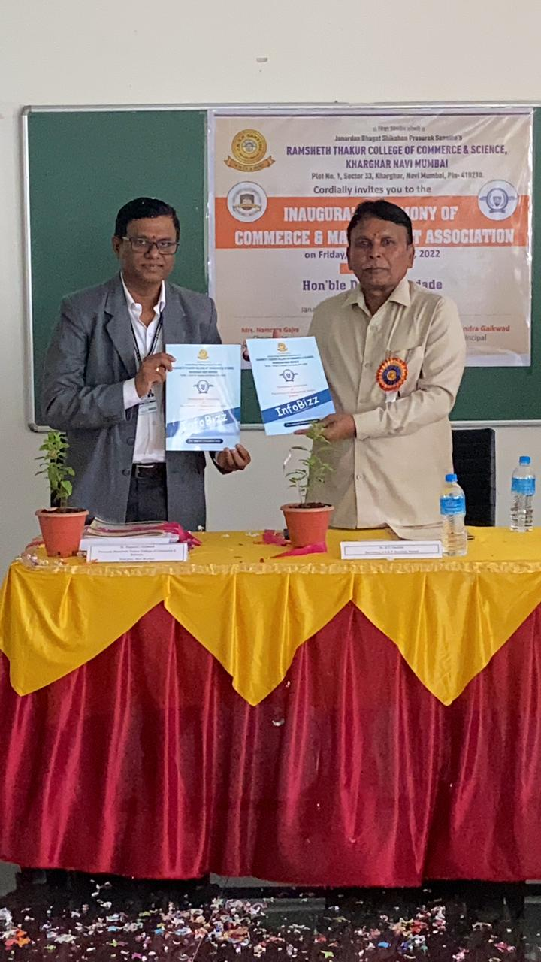

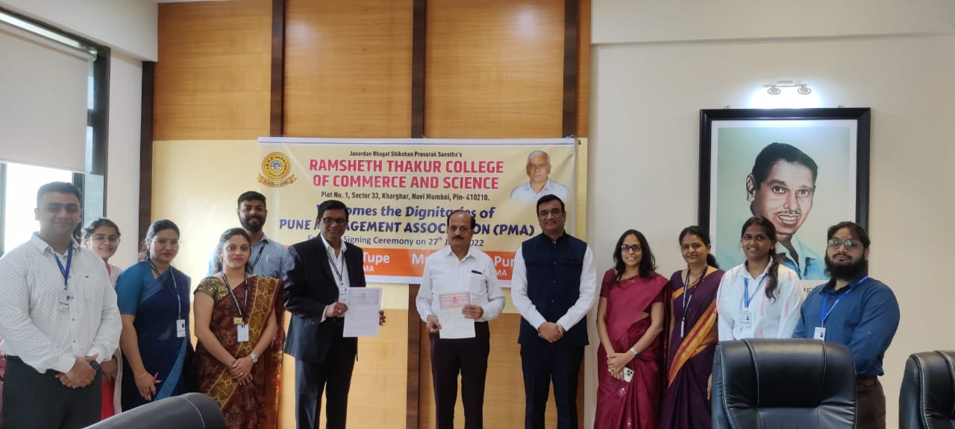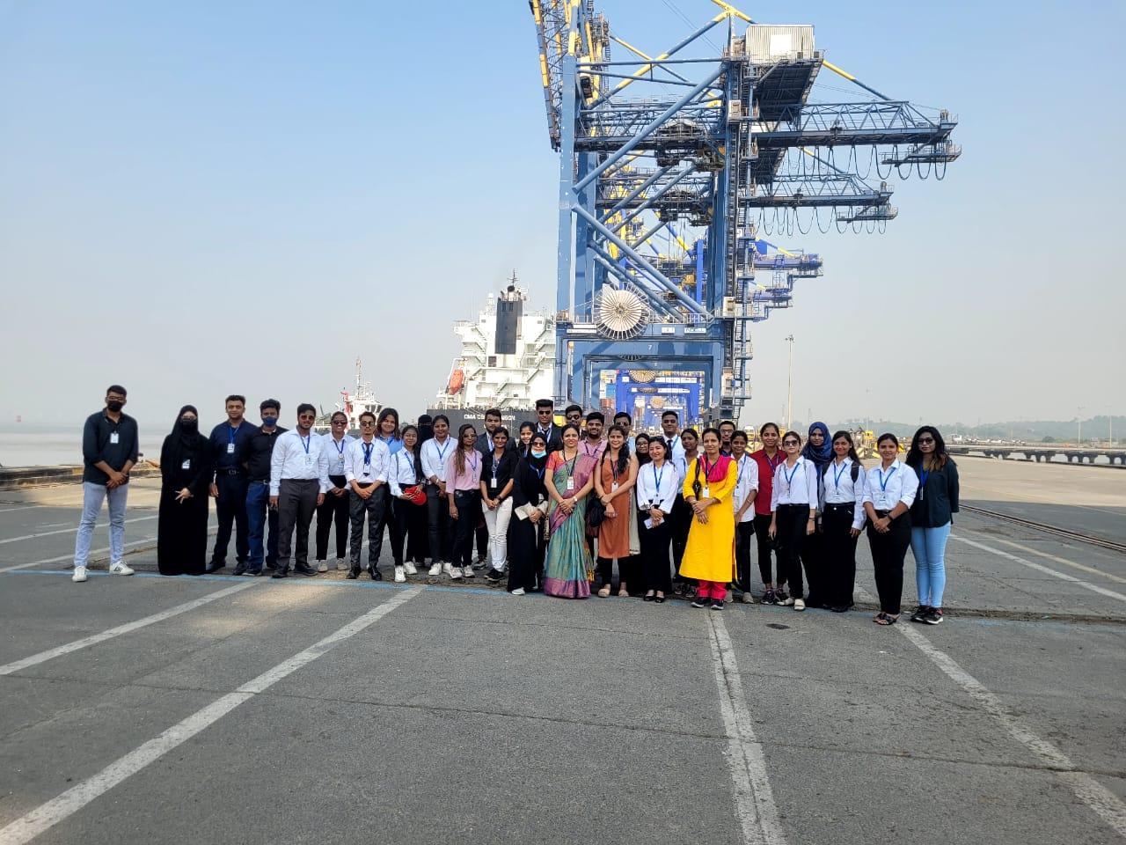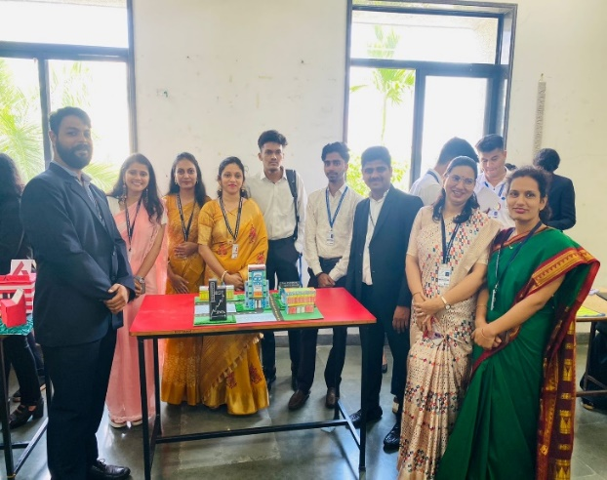

Visit To JNPA

Unveiling of First Volume of Infobizz Magazine held on 23rd September, 2022

MoU Signing Ceremony with PMA

Model Making Competition

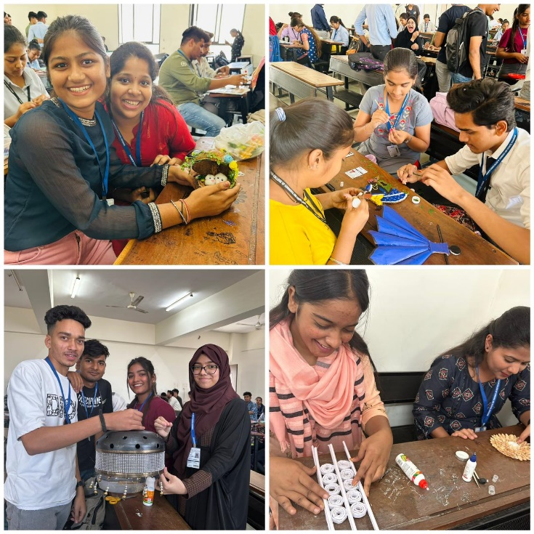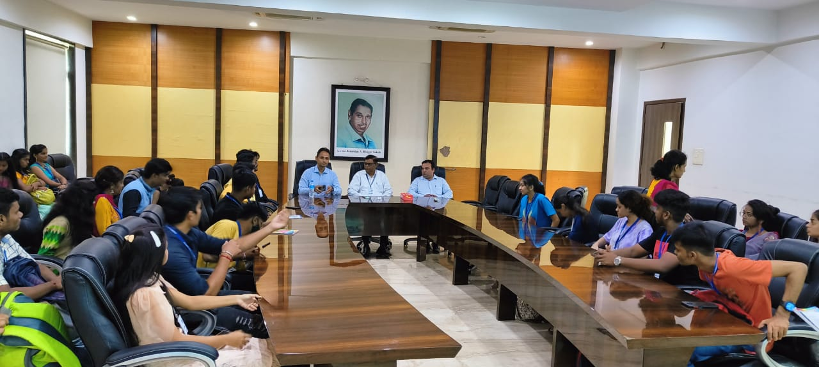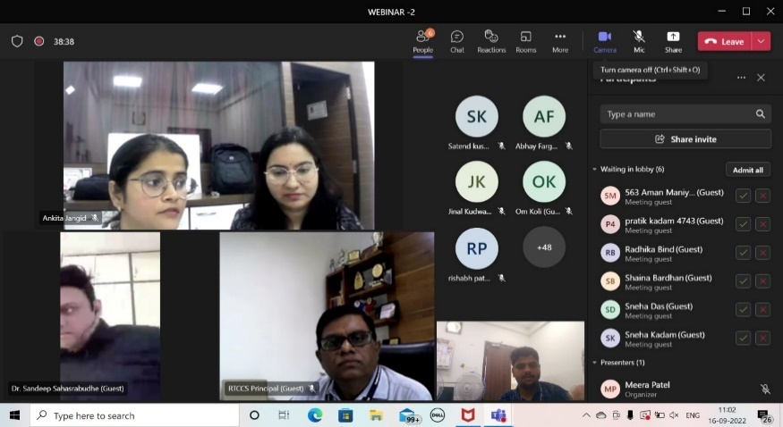

Webinar on “Investment for Individuals” with Expert speakers from PMA

Seminar on “Risk Management” with Expert speakers from PMA

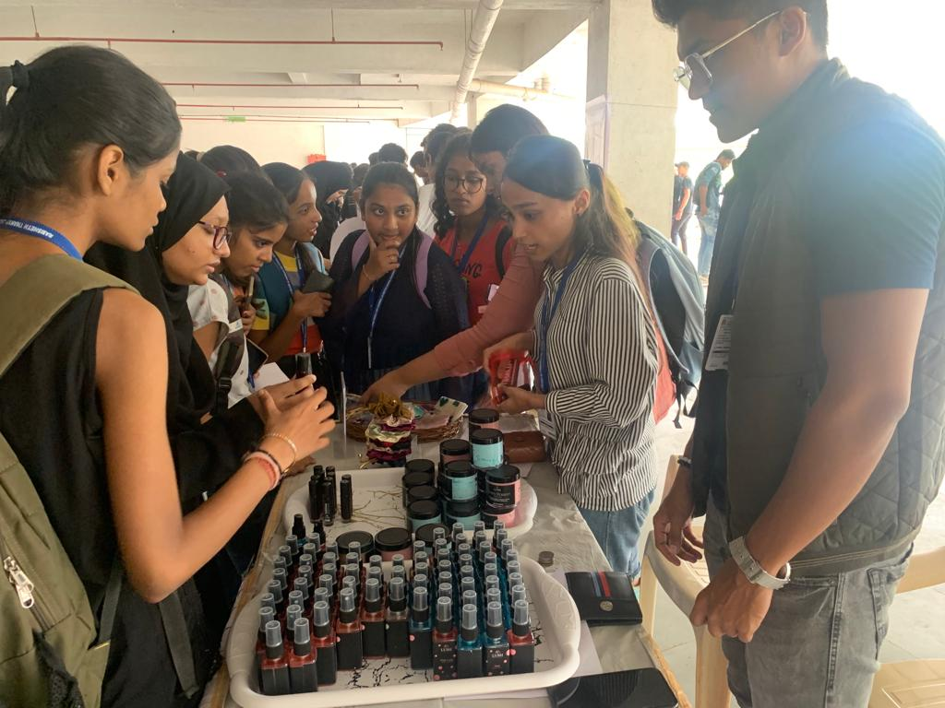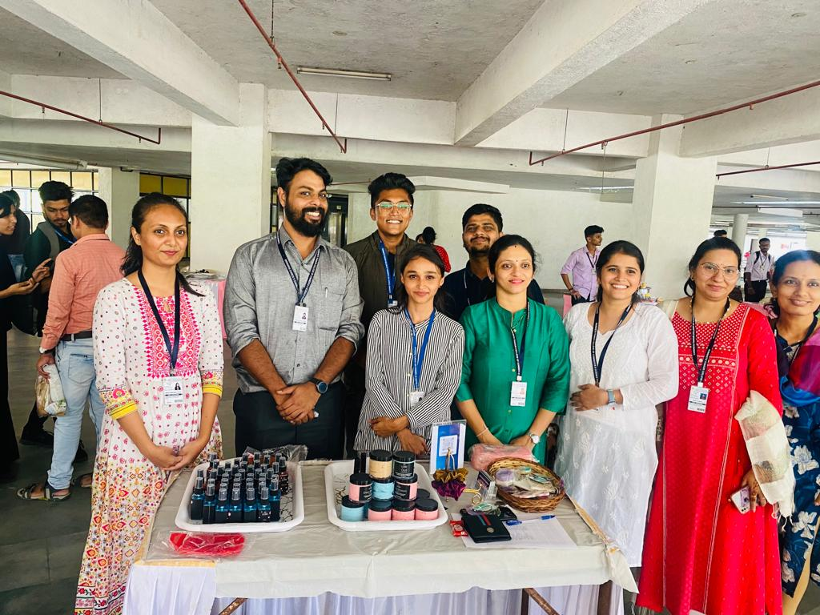

Point-of- Sale activity organised by Management Association

Best-Out of- Waste activity organised by Management Association